" Credit Derivative instruments can boost Real Estate Market and help Banks alleviate NPA "

Introduction:
In this Paper we examine Credit Derivative instruments engineered by the Structured finance Industry namely ABS , MBS and then Securatization and collateralization techniques followed by CMO , CDO and CDS to demystify them . We further suggest how Indian banks can pool risks and separate risks using these tools and thus help Indians borrow to buy a house by tailoring the mortgage payment terms to suit individual cash flow estimates ( Adjustable Rate Mortgages ) and the banks to create more assets without being dependent on the deposits. Indeed going forward with declining Interest rates deposit mobilization will dwindle .
Ground work
Before we can delve into deeper discussion we prepare the groundwork by explaining a few concepts in a simple yet adequately technical way doing away with most jargons.
Key Concepts:-
- Credit risk
Credit risk is the risk of loss due to a counterparty's failure to perform on an obligation to the institution Eg: Kingfisher airline’s default to pay interest or repay the loan to the Banks created a credit risk for the banks.
To Manage such a risk ie Credit risk we have derivative products that comes in two forms:
Pre-settlement risk is the risk of loss due to a counterparty defaulting on a contract during the life of a transaction. The level of exposure varies throughout the life of the contract and the extent of losses will only be known at the time of default.
Settlement risk is the risk of loss due to the counterparty's failure to perform on its obligation after an institution has performed on its obligation under a contract on the settlement date. Settlement risk frequently arises in international transactions because of time zone differences. This risk is only present in transactions that do not involve delivery versus payment and generally exists for a very short time (less than 24 hours).
- Classification of Bonds on the basis of Risk.
Credit Risk is High for High yielding bonds and low for Investment grade bonds
Interest rate risk is high for low coupon high grade bonds while its low for floating rate bonds.
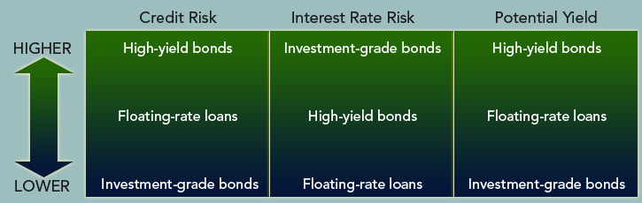
- Mechanics of Creating Securities with different characteristic than the original securities
We will now explain in the numerical illustration given below how the cash flows from a bunch of securities can be sliced and diced and other instruments created.
Case 1: A SPV called MC is created to buy 3 bonds trading at Par with varying life say a corporate bond yielding 9% with varying life and from that the coupons are stripped and a zero coupon bond is created. 10 zero coupon bonds using Interest cash flows from the three bonds and 3 zero coupon bonds using the Principal cash flows from the three bonds are created and in all 13 bonds are sold to investors today. The bonds are priced using the comparable Yield curve for which the SBI fixed deposit rates have been used and a spread to attract the investor is used.
Upon looking at the mechanics one can easily realize how important it is for MC SPV to ensure that the Bonds A,B and C does not default and are sufficiently high grade. Should the bonds default then MC SPV will default to its 13 investors.
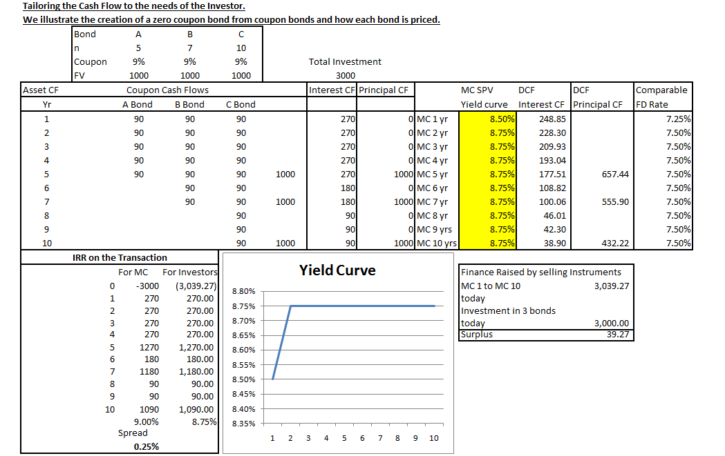

A lot of deep concepts one can understand from the above case study. A) Creation of Zero Coupon Bonds from Coupon Bonds B) Pricing the Zero Coupon Bonds by using a referenced Yield curve and taking a spread over it. C) Internal rate of Return’s practical application. D) Once modeled on a Spreadsheet one can run a simulation analysis.

After going through the above concepts now let us see what are the securities we are recommending to package and sell different instrument to investors?
I We are recommending those securities backed by a pool of loans or receivables—mortgage-backed securities and asset-backed securities.
The mortgage-backed securities sector , simply referred to as the mortgage sector of the bond market, includes securities backed by a pool of mortgage loans. There are securities backed by residential mortgage loans, referred to as residential mortgage backed securities, and securities backed by commercial loans, referred to as commercial mortgage-backed securities.
Securities backed by loans other than traditional residential mortgage loans or commercial mortgage loans and backed by receivables are referred to as asset-backed securities.
Now we shall provide information on Indian Residential and Commercial Real Estate market.
Demand for Housing
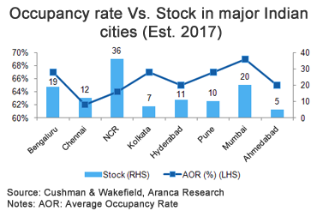
Notice that Barring the NCR Region everywhere the Demand outstrips supply.
Now let us look at Commercial Real Estate Market
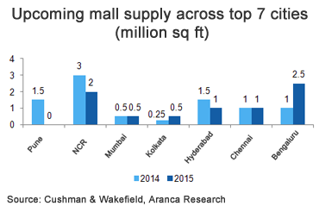
Now let us see what the market is growing. The Investors make money investing in Real Estate.
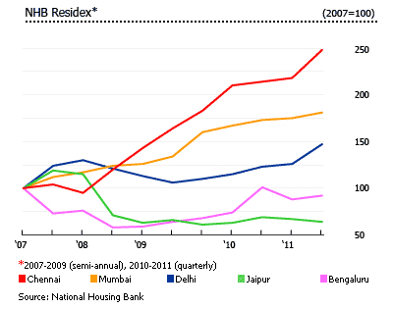
The above chart shows that Chennai Property market was followed by Mumbai and Delhi in the price increase. These three cities showed a positive return to their Investors while Investors in Bangalore and Jaipur are under water. These kinds of Index is a very useful tool to engineer Swaps between developers in two cities who could use this index as a referenced asset to enter into a swap.
Thus having established the growing demand for housing space and commercial real estate we believe that , mortgage-backed securities and asset-backed securities referred to as structured ﬁnancial products are a must for financing the end consumer to help Real Estate market grow. Real Estate sector ties up with 270 other sectors in the economy and this is why we need to ensure that latest tools to finance the borrowers and manage the credit risk , prepayment risk .
Framework for Structured Finance Products to be available in India:-
- Central Government Backed Financial Institution Providing large scale mortgage financing.
- Market for the above agency to access new finance by selling its instruments on an ongoing basis.
- Government guarantee to ensure the above securities do not default and are thus risk free.
- Allowing Private financiers to provide similar financing and sell their securities .
Credit risk should not exist for the Central Government Backed Financial Institution. This is critical because these securities will form the raw material which will be packaged and sold to investors to recycle capital.
Another signiﬁcant risk is prepayment risk and there are ways to redistribute prepayment risk among the different bond classes created. Thus first a robust market for this Central Government Backed Financial Institution’s securities must develop. Secondary market, market makers and brokers willing to participate and give quotes in even adverse conditions must be developed . The technology developed for creating such a mortgage backed security guaranteed by Central Government can then be transferred to package and securitize of other types of loans and receivables. In transferring the technology to create securities that expose investors to credit risk, mechanisms have to be developed to create securities that could receive investment grade credit ratings sought by the issuer.
Speciﬁcally, asset-backed securities include mortgage-backed securities as a subsector. While that is actually the proper way to classify these securities, it was not the convention adopted in the United States
Residential mortgage-backed securities include: (1) mortgage passthrough securities, (2) collateralized mortgage obligations, and(3) stripped mortgage-backed securities. The latter two mortgage-backed securities are referred to as derivative mortgage-backed securities because they are created from mortgage passthrough securities.
RESIDENTIAL MORTGAGE LOANS
A mortgage is a loan secured by the collateral of some speciﬁed real estate property which obliges the borrower to make a predetermined series of payments. The mortgage gives the lender the right to ‘‘foreclose’’ on the loan if the borrower defaults and to seize the property in order to ensure that the debt is paid off. The interest rate on the mortgage loan is called the mortgage rate or contract rate. When the lender makes the loan based on the credit of the borrower and on the collateral for the mortgage, the mortgage is said to be a conventional mortgage. The lender may require that the borrower obtain mortgage insurance to guarantee the fulﬁllment of the borrower’s obligations.
The cost of mortgage insurance is paid by the borrower in the form of a higher mortgage rate. There are many types of mortgage designs used throughout the world. A mortgage design is a speciﬁcation of the interest rate, term of the mortgage, and the manner in which the borrowed funds are repaid. The alternative mortgage designs include (1) ﬁxed rate, level-payment fully amortized mortgages, (2) adjustable-rate mortgages, (3) balloon mortgages, (4) growing equity mortgages, (5) reverse mortgages, and (6) tiered payment mortgages. Other countries have developed mortgage designs unique to their housing ﬁnance market. Some of these mortgage designs relate the mortgage payment to the country’s rate of inﬂation. Below we will look at the most common mortgage design in the United States—the ﬁxed-rate, level-payment, fully amortized mortgage. All of the principles we need to know regarding the risks associated with investing in mortgage-backed securities and the difﬁculties associated with their valuation can be understood by just looking at this mortgage design.
A. Fixed-Rate, Level-Payment, Fully Amortized Mortgage A ﬁxed-rate, level-payment, fully amortized mortgage has the following features:
• the mortgage rate is ﬁxed for the life of the mortgage loan • the dollar amount of each monthly payment is the same for the life of the mortgage loan (i.e., there is a ‘‘level payment’’) • when the last scheduled monthly mortgage payment is made the remaining mortgage balance is zero (i.e., the loan is fully amortized).
Now let us get an overview of the existing market and players in the housing finance market.
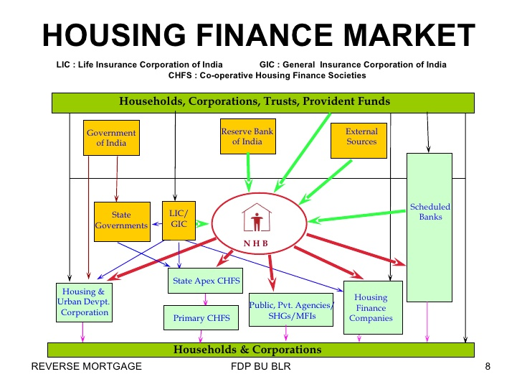
Each of the above players can be understood as suppliers of papers which can be pooled and sold to willing investors. Now when the borrower repays the loan it will pass through these institutions and be received the the investors. Thus these players who are funding the borrowers to buy homes will on the other hand sell Pass through certificates to investors who will go on receiving cash from what the borrowers pay these institutions. Should the borrowers default then these institutions will be on the hook. Below we notice the year on year climb in
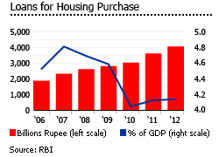
the loans disbursed , It’s a study climb. It can be exponential if only Structured finance products were allowed. Now we shall look at the Evolution of Structured Finance Products and understand the flow.
Securitization: Using illiquid assets as a raw material creating securities that are tradable in the market is the process of Securitization. Using this techniques banks can get rid of their illiquid asset Eg: a 30 year loan on which the bank is collecting monthly repayment and interest income from the borrower is an illiquid asset.
ABS: Asset Backed Securities are instruments which promise to give its investors the share in the cash flows generated by the assets that back these instruments. Eg: Student Loan portfolio can be used to construct Pass through certificates. When the students repay their loan the cash is passed on to the Investors.
MBS: Mortgage Backed Securities are instruments which priomise to give its investors the share in the cash flows generated by the housing loans that back these instruments. Eg: When home owner who borrowed money from the bank to buy a house now repays his loan in a monthly installment the cash is handed over to the investors. This instrument is safer than a ABS because people will usually not default on Mortgage payment. However there is a risk of Prepayment.
Both ABS and MBS are essentially Pass Through Certificates. The Investors are not given any preferential rights to receive cash flow nor are they offered any protection in case of any defaults of prepayment. Democracy prevails and ALL are Equal. Fannie Mae and Freddie Mac were the first Institutions to create such instruments way back in the 1970’s to recycle capital. Necessity is the mother of Financial Innovation. Due to persistant low interest rates and a prevailance of Equity investment among general population institutions fail to attract deposits to make fresh loans. Thus they need to recycle capital by shortning the duration they hold the assets.
The Game : Make a loan. 8000 of them . Bundle the papers and put them in a box and sell it to an SPV ( Special Purpose Vehicle ). The SPV securitises the loan and creats Pass Through Certificate and sells the same to millions of investors areound the world. When you receive the cash from your borrower hand it over to the SPV which inturn hands most of it over to the investors. The more the volume of loans you make more you can sell to the SPV. These SPV’s are usually domeciled in a Tax heaven . Should your borrowers default the Pass through certificate is a lemon.
Collateralization: This is a process of creating different class of securities from the same underlying pool of Mortgages or student loans. Each class has different rights over the cash flow collected from those repaying their loans. Each class has a different obligation should their arise a default or should their occure a prepayment. Each inferior trench or class of securities created are offered as a collateral to the trench above it. Highest is typically rated AAA by using other credit enhancement tools while the most inferior is called Equity trench and thus is not rated.
Case 2
How does a CDO work? How is it constructed, maintained and managed over its life?
Souupose an SPV purchases two BBB rated Bonds worth 400 million by selling Instruments to investors graded from AAA to BBB as shown below. The SPV collects interest on the BBB rated bonds and distributes the interest to investors.
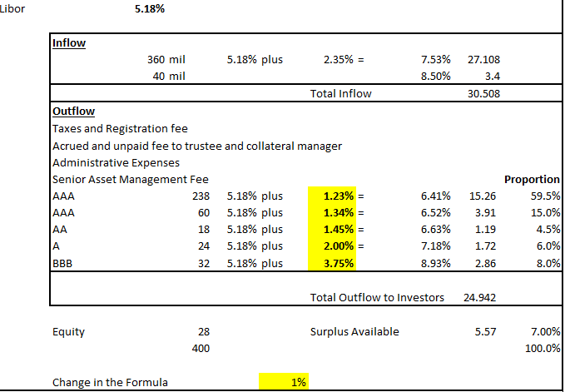
Two Bonds graded BBB $ 360 million Principal with coupon L+2.35% and $ 40 Principal with coupon 8.5% and pooled and $238 million AAA Sr coupon L+1.23%; $ 60 million AAA Jr coupon L+1.34%, $ 18 million AA graded coupon L+ 1.45%, $24 million A Graded coupon L+2% and $32 million BBB graded Coupon L+3.75% are issued. Total Interest received in $ 30.508 and Total Interest Outflow is $ 24.942 leaving a surplus of $ 5.57 million.
Securities issued is for $ 372 million while the institution retains $ 28 million worth exposure in Equity Trench which stands ready to face losses on account of default or prepayment.
In the table below we construct the surplus on column Y and see the surplus if Libor fluctuates. The spread is positive for a wide range of possible LIBOR Values. Higher the surplus greater is the return for the equity trench. The last column in the table examins if there is a increase of 1% in the interest we pay our investors due to downgrading of our papers due to declining credit quality.

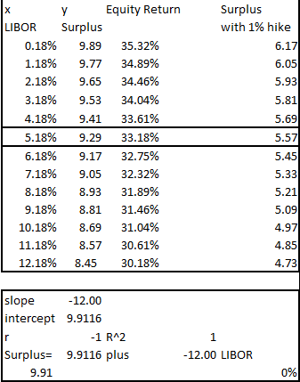
Principal Cash flow is apportioned to the trenches adopting the water fall model. Till the senior trenches are paid off the junior trenches get nothing. Here we have adopted a repeated distribution method to pay more trenches sumultainously. This makes the discussion more complex than it needs to be. Each trench can be visualised as a Bond with varying duration. And thus each trench can be valued using the same principles of valuation useld elsewhere in finance. Cash flows discounted using an appropriate risk adjusted discount factor. Risk of each trench can be tailored and returns caliberated accordingly. The lower trenches find favour with Hedge funds while the higher more secured trenches find favour with Pension fund and Insurance companies. Thus for each trench there is a market. If there are trenches left over then such trenches can be pooled yet again to form new CDO. Mostly Mezzanine trenches that are difficult to sell are pooled together to form another structure and similar process of collateralization is once again done.
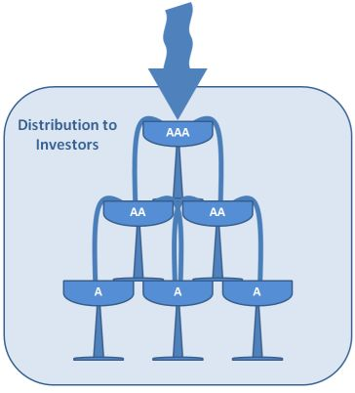

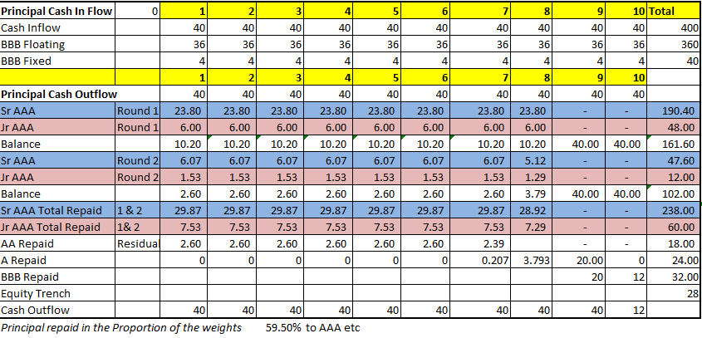
The Table below shows the Balance outstanding for each of the years of the life of the CDO
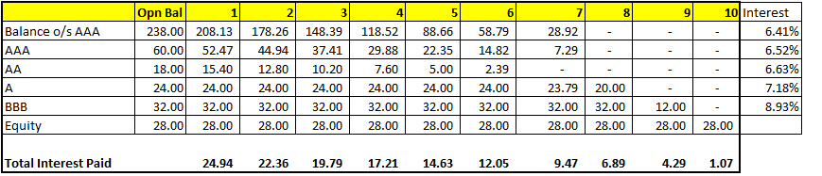
The Table below shows the Balance outstanding for each of the years of the life of the Bonds we hold as Asset.
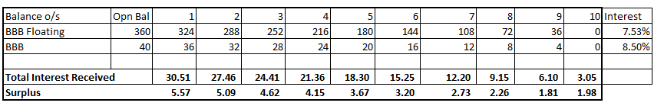
In the P/L extract given below we have only few items. Interest received and Interest paid. Usually these SPV’s are domiciled in a tax heaven so there is no tax and thus the net income acrews. Its almost always positive. In order to secure the position of the AAA grade instrument holders we further pay a CDS ( Credit default swap ) premium .
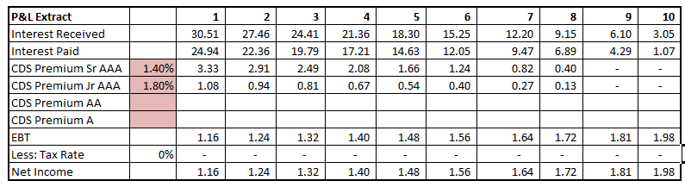
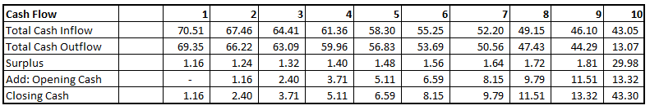
Notice that the cummulative net income is nothing but the positive cash balance. Since there is no requirement for any fixed assets like furniture there is no depreciation. Multiple CDO’s can be maintained by a single person. This is the reason why it is enormously profitable and why banks were so much into this market till the fundamentals were shaken by the subprime market crisis that took the Global Financial markets into a tail spin.
Blaming CDO or allied products for the financial crisis is the easiest thing we can do. A fire that gives us illumination in the dark can also burn down our house. The fault is not of the fire but us.
This paper is ment to explain the nature and pupouse of the Securitized Instruments and Collateralised Instruments. One hopes that with a clear understanding provided in this paper the academic and research community within India is in a better shape to debate whether these instruments must be made available so that it helps manage risks better , make markets more robust and deliver higher levels of prosperity.
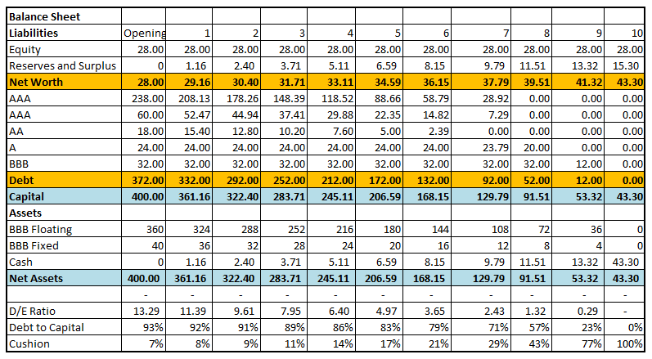
Thus in 10 years supposing there is no default and the investors are paid off then the Equity trench would have earnt a CAGR of (43.3/28)^(1/10)-1= 4.46%
Thus the financial institution successfully engaged in buying inferior graded bonds and sold securities backed by those bonds , performed its obligation and enriched by $43.3 million over a 10 year period by only working the phones to undertake the marketing effort and ensuring that the assets are of sufficiently good quality so that it does not default ( counter party must not default ).

Credit Default Swap
Issuers of CDO’s find it a compulsoion to hedge against the probable default of the Originators. Should the originator default then the SPV that has issued the CDO will default to the investors. The top two trenches will get a AAA rating only if a AAA rated insuror like AIG offers protection against the default of the originator. It can be with or without recourse. There may be a cap or there may be a condition that only up to the value of the collateral the insurer will make the payout. Should the default occure the SPV will deliver the bonds to the Insurer and get the payment and thus will not have to default to their investors. Here Risk buyer ( Insurer ) offers the Risk Seller ( CDO issuer ) a protection against the default of a referenced asset ( Bonds of the originator held by the SPV which has issued the CDO) for periodic payments which depend on three factors. Interest rates, Default probability and Recovery Rate.
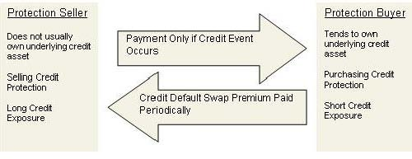
The Issuer of the CDO has to purchase the protection on the basis of the prevailing premium quoted in Basis Points.
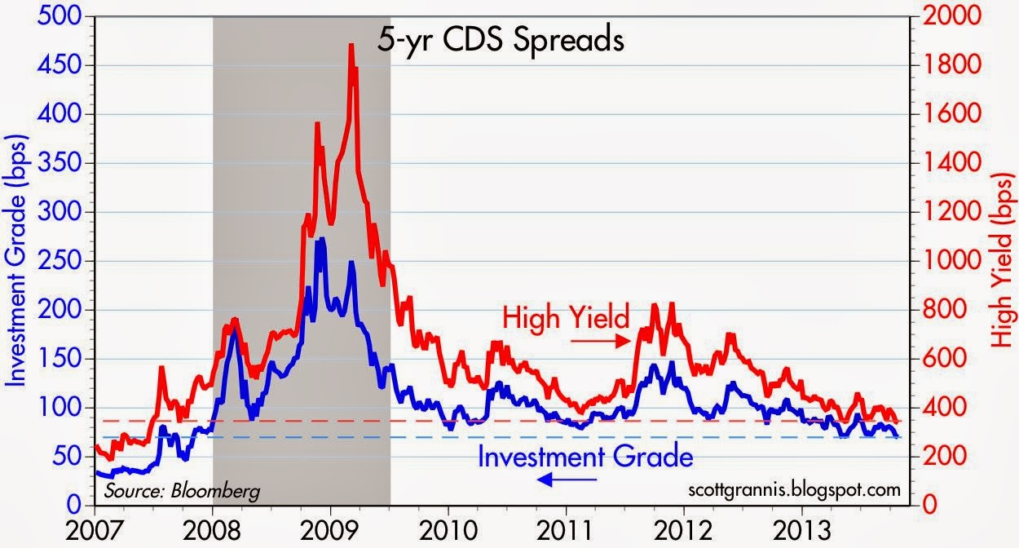
By late 2013 the premium to be paid to buy protection for an investment grade bond was 300 BP. Thus if one has issued Rs 1000 cr worth of CDS then 3% is the annual premium required to be paid ie 30 cr .
There are three components that decide this premium. Default Probability, Recovery rate ie how much can be recovered once the default has occurred either by selling the collateral or proceeding against other assets of the borrower.
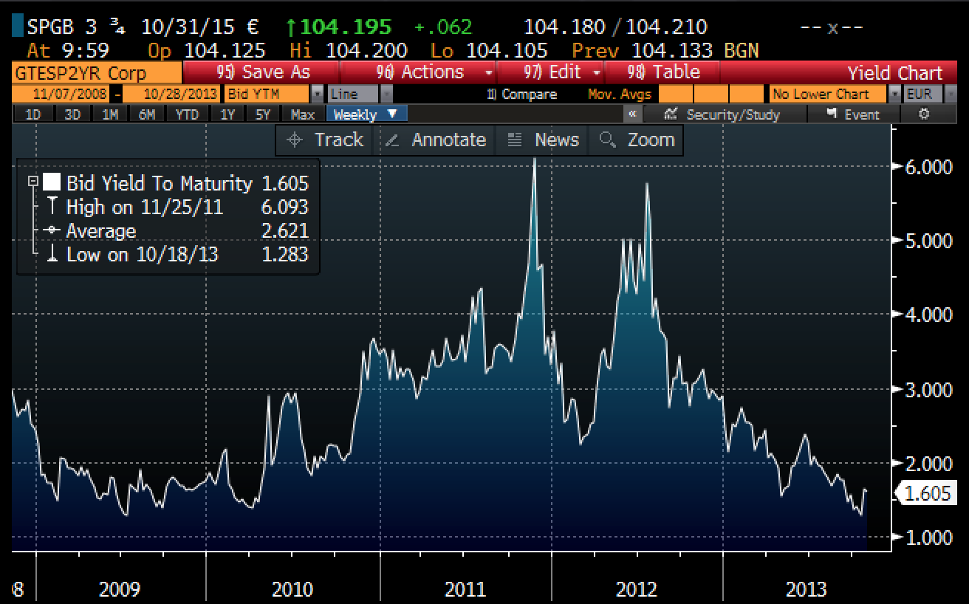
The chart above shows CDS spreads on Spanish 5-yr sovereign debt. After peaking in 2012, spreads have plunged, reflecting a significant decline in Spain's default risk.

Bad Loans Problems in India
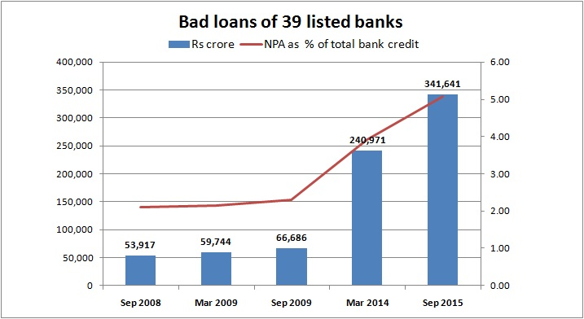
Derivatives can not solve problems created by poor credit administration and practices done in a hurry to build the books. If the borrowers within the system have no income , no assets and no jobs then the banks can not hope to lend to such borrowers and package the loans and sell the mortgage to an SPV the whole system will collapse . The problems created by over zelous sales department paid on the basis of incentives alone can not be solved by Financial Engineering. A matured process driven method of assessing creditworthiness and maintaining Loan to Value Ratio is the building blocks of creating Securitized instruments to lend liquidity to these illiquid assets.

Appendex:
Permissible derivative instruments by RBI
At present, only Interest Rate Derivatives and Currency Derivatives instruments are permitted, subject to certain conditions:
- Interest rate derivatives – Interest Rate Swap (IRS), Forward Rate Agreement (FRA), and Interest Rate Future (IRF).
- Foreign Currency derivatives – Foreign Currency Forward, Currency Swap and Currency Option.
Rupee Interest Rate Derivatives
(a) Product Market:
(i) Over the Counter (OTC) – Forward Rate Agreements &
Interest Rate Swaps
(ii) Exchange Traded – Interest Rate Futures
(b) Products:
(i) Forward Rate Agreement (FRA)
(ii) Interest Rate Swap (IRS)
Eligible entities can undertake different types of plain vanilla FRAs/ IRS. Swaps having explicit/ implicit option features such as caps/ floors/ collars are not permitted.
(iii) Interest Rate Futures (IRF)
(c) Benchmark Rate/s for FRA/ IRS
Any domestic money or debt market rupee interest rate; or, rupee interest rate implied in the forward foreign exchange rates, as permitted by RBI in respect of MIFOR swaps.(cf paragraph 3 of DBOD Circular No. DBOD.BP.BC. 53/ 21.04.157/ 2005-06 dated December 28, 2005)
(d) Participants
Users
Scheduled Commercial Banks (excluding Regional Rural Banks), Primary Dealers, specified All-India Financial institutions (AFIs) and corporate entities, including Mutual Funds.
Market-makers
(i) For Forward Rate Agreement / Interest Rate Swap - Scheduled Commercial Banks (excluding Regional Rural Banks) and Primary Dealers.
(ii) For Interest Rate Future – Primary Dealers.
(e) Purpose:
Users
(i) For hedging underlying exposures
(ii) Banks, PDs and AFIs can undertake FRA/ IRS to hedge the interest rate risk on any item(s) of asset or liability on their balance sheet.
(iii) Banks may undertake interest rate futures transactions to hedge the interest rate risk on their investments in Government securities in AFS and HFT portfolios.
(iv) PDs may hold trading position in IRF, subject to internal guidelines in this regard.
Foreign exchange derivatives
(i)Foreign exchange forwards
(ii) Cross currency swaps
(iii) Foreign currency rupee swaps
(iv) Cross currency options
(v) Foreign currency rupee options
There are four main modifications to the instructions contained in the extant guidelines issued by Foreign Exchange Department, RBI with regard to the above instruments, viz;
(i) Users, such as importers and exporters having crystallized (evidenced by firm order, opening of LC or actual shipment), un-hedged foreign exchange receivables and payables in respect of current account transactions may write covered call and put options in both foreign currency/ rupee and cross currency and receive premia.
(ii) Market-makers may write cross currency options.
(iii) Market-makers may offer plain vanilla American foreign currency-rupee options.
(iv) A person resident in India, who has a foreign exchange or rupee liability, is permitted to enter into a foreign currency rupee swap for hedging long-term exposure. For purposes of clarity, the term "long-term exposure" may be defined to mean "exposure with residual maturity of three years or more".
Products
i. Foreign Exchange Forwards
(a) Participants
Users
- Persons resident in India with crystallized foreign currency / foreign interest rate exposure, as permitted by RBI
- Persons resident outside India with genuine currency exposure to the rupee, as permitted by RBI
Market-makers
- Authorised Dealers Category – I Banks
(b) Purpose
(i) Residents in India
- To hedge crystallized foreign currency / foreign interest rate exposure
- To transform exposure in one currency to another permitted currency.
(ii) Residents outside India
- To hedge or transform permitted foreign currency exposure to the rupee, as permitted by RBI.
ii Foreign Currency Rupee Swap
(a) Participants
User
- A person resident in India who has a long-term foreign currency or rupee liability
Market-makers
- Authorised Dealers Category – I Banks
(b) Purpose
Users
- To hedge or transform exposure in foreign currency / foreign interest rate to rupee / rupee interest rate
Market-makers
- Can only take up residual positions, as permitted by RBI and not allowed to run a book.
Iii Cross Currency options
(a) Participants
Users
- A person resident in India with crystallized foreign currency exposure, as permitted by RBI.
Market-makers
- Authorised Dealers Category – I Banks, approved as market-maker by RBI.
(b) Purpose
Users
- To hedge or transform foreign currency exposure arising out of current account transactions
Market-makers
- To cover risks arising out of market-making in foreign currency rupee options as well as cross currency options, as permitted by RBI
iv Foreign Currency Rupee Options
(a) Participants
Users
- Customers of market-makers who have genuine foreign currency exposures, as permitted by RBI.
- Authorised Dealers Category - I Banks for the purpose of hedging trading books and balance sheet exposures.
Market-makers
- Authorized Dealers Category-I Banks, approved by RBI.
- Authorized Dealers Category-I Banks who are not market-makers can write foreign currency rupee options on a back-to-back basis, provided they have a CRAR of 9% or above.
(b) Purpose
- To hedge currency exposure
v. Other Products
For certain specific purposes, RBI has permitted the use of cross currency swaps, caps and collars and FRAs. For example, entities with borrowings in foreign currency under ECB are permitted to use cross currency swaps, caps and collars and FRA for transformation of and/or hedging foreign currency and interest rate risks. These three products can be offered only for the purposes specified by RBI and not otherwise. Use of any of these products in a structured product not conforming to the specific purposes is not permitted.
In respect of foreign exchange derivatives, market participants may be guided by the instructions issued by Foreign Exchange Department, RBI from time to time to the extent indicated in these guidelines. The instructions contained in this circular are broad principles providing a framework, while the operational guidelines, as provided in the Master Circular on Risk Management and Inter-Bank Dealings will be reviewed from time to time under this framework.

