FAQ regarding Equity Investments

We answer 9 questions in this article

- Which is the best month in to invest in stocks
- Which is the worst month for stocks
- Which month the risks are least
- Which month the risks are highest
- Are the monthly returns correlated?
- Which are the months we are likely to see a positive returns?
- What are the average annual returns an investor has earn’t in the market?
- Do Positive returns follow positive returns.
- Do Negative returns follow negative returns.
If we knew the months the markets gave positive return with a higher probability than negative returns we could at least be active in those months and even if we avoided dabbling in stocks in other months we would have a higher probability of earning superior returns than we could on other asset classes. So here We have tabulated the past 231 months monthly returns in the table given below and segregated the positive and negative returns.
We then calculate the Total returns, Average returns, Monthly standard deviation which represents the risk.
Turns out that January and October are the worse months to buy stocks. The Average returns made by investors in January was -1.34% and October it was -8.95%. Clearly these two months emerge as the months to avoid .
May is the month where markets can be expected to be very volatile and thus very risky to dabble in stocks. At 10.6% risk May can dent a serious hold in your trading capital.
December not only has provided the highest returns historically but has also exposed the investors to lowest standard deviation ( measure of risk of investing in stocks) . Call it Santa Rally or the month where FIIs are loading up on their portfolio you can not afford to miss the season to invest in stocks which is clearly November and December.
From the analysis below June, July, November and December turns out to be the best months to invest in stocks. The Probability of Positive returns far outweighs the probability of negative returns.
We find no correlation between returns of February with January and so on. Which means there is no evidence which suggests that if January goes badly the february will follow suit or March returns are somehow determined by February returns.
We further find that Positive returns follow positive returns and negative returns follow negative returns for about 70% of the time while negative return follows a positive return and vice versa 30% of the time. 56% months we saw positive returns and 44% months saw negative returns.
An investment of Rs 100 in Only January would grow
To a value of January 73.96 , February102.51 , March 113.58 , April 107.13 , May 114.51 , June 118.57 , July 133.03 , August 105.02 , September 134.58 , October84.54 , November149.07 and December 186.19
Off late we are finding the returns and risk both are falling and that is likely to change because high returns follow a long spell of low returns.
The Proportion of Months where returns were positive to the months the returns were negative is most favourable in the case of December. 14 advancing Decembers with only 5 declining Decembers. But January was a different story altogether.
The fact that we are not able to identify a pattern or a trend is actually an indication that stock market is random and thus the returns are random. Had it not been random and if we could stop a trend then all investors would similarly spot the trend and wait to trade till the trend disappears. December Rally called the santa rally and January effect seems to be visiable in our markets too like other markets. Thus we can say that our markets are also a Semi Strong form efficient market where all publcily available current and historical information is factored into the price of the stock.

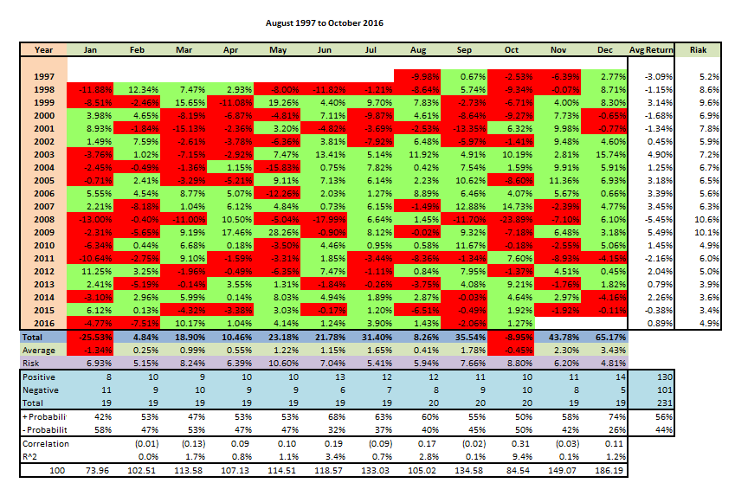
MENTES CAPITAL
WEB - WWW.MENTESCAPITAL.COM
PH.NO. - +91-9886751703, +91-9916570093
ADDRESS- #164,9th Cross, Indiranagar 1st Stage, Bangalore 560038

DISCLAIMER
*****************************************************************************
This information/email sent by Mentes capital may express financial guidance but these recommendation, advice, or guidance does not account for specific and particular financial goal and any suggestions, opinions conclusions stated in this information/email endorsed by us unless it is assigned. Mentes capital does not warrant the accuracy of any such information or appropriateness of any transaction. The information through this electronic communication and any attachments are for informational purposes only and no circumstance should they be affirmed as an offer to sell or a solicitation to buy any of Mentes products or any such reports. Risk of loss can be of any amount on this investment. You should take all the precaution while trading and investing is suitable for you in light of your experience, goal and other relevant circumstances. Mentes capital and its associate, employees, partners, subsidiary branch shall not be liable for any losses incurred by you. Trading and investments in financial markets are subjected to market risks therefore advised to seek professional support. There is no guarantee/assurance as to returns, capital protection and appreciation. It’s the sole responsibilities of the investors and traders for any decision taken by them. Any information in the email attachment is for recipient personal and confidential use. It is affirmed that dissemination, distribution or copying this information is strictly prohibited. There is a risk of modification in the information due to electronic nature of email. It’s not guaranteed that messages are virus free, malicious code. We are not liable for virus free. Please contact your relationship manager for more information on these risks. Past performance of actual trades or strategies cited herein is not necessarily indicative of future performance.
For detail disclaimer go to our website www.mentescapital.com.

