Investment Philosophy for 2016
Market Overview:-
We recommend a selective contrarian Investment strategy for 2016. As we see in January 2016 the Oil prices provide a big overhang for the Equity Markets. Yesterday US markets had a single largest point drop in the opening. Global markets are still in turmoil with China still volatile. The ViX in India is at 15% and we thus recommend buying very selectively and very cautiously .
We continue to believe India will provide a good hedge against the declining global equities with a robust growth as envisaged by World Bank. A 7.7% growth in GDP will come on the back of Industrial Production growth, credit off take and Automobile sales. Growing Middle class consumption requirements will increase Corporate Earnings and Schemes like Make In India will effect large scale industrial production of capital goods equipment. Therefore the Macro Economic factors both domestic and India’s IT exports looks placed to show good growth in 2016. The only dark cloud is the currency value. Indian rupee continues to come under pressure with mounting fiscal deficit and current account deficit fueled with oil imports. The recent spurt in Oil prices will only add to the voes.
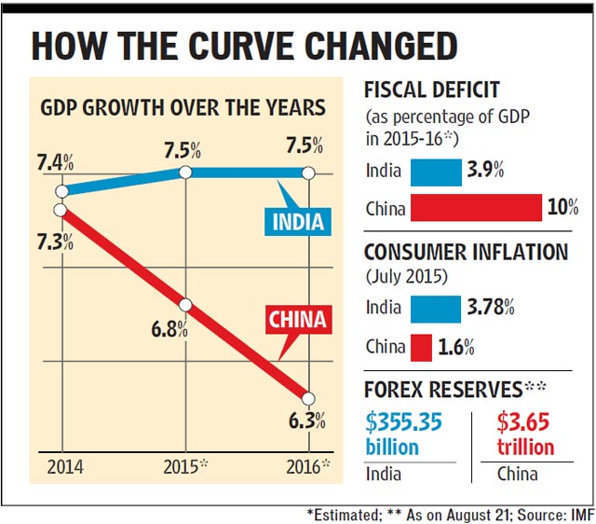
The only cause of concern in the above data set is the Consumer Inflation fueled by profiteering and hording on the one hand and supply side constrains on the other. With economic growth will come higher capital inflows increasing forex reserves.
Memories are very short , lets just look at 2013 and how euphoric the markets and investors were. It’s a cycle what goes down will come up.
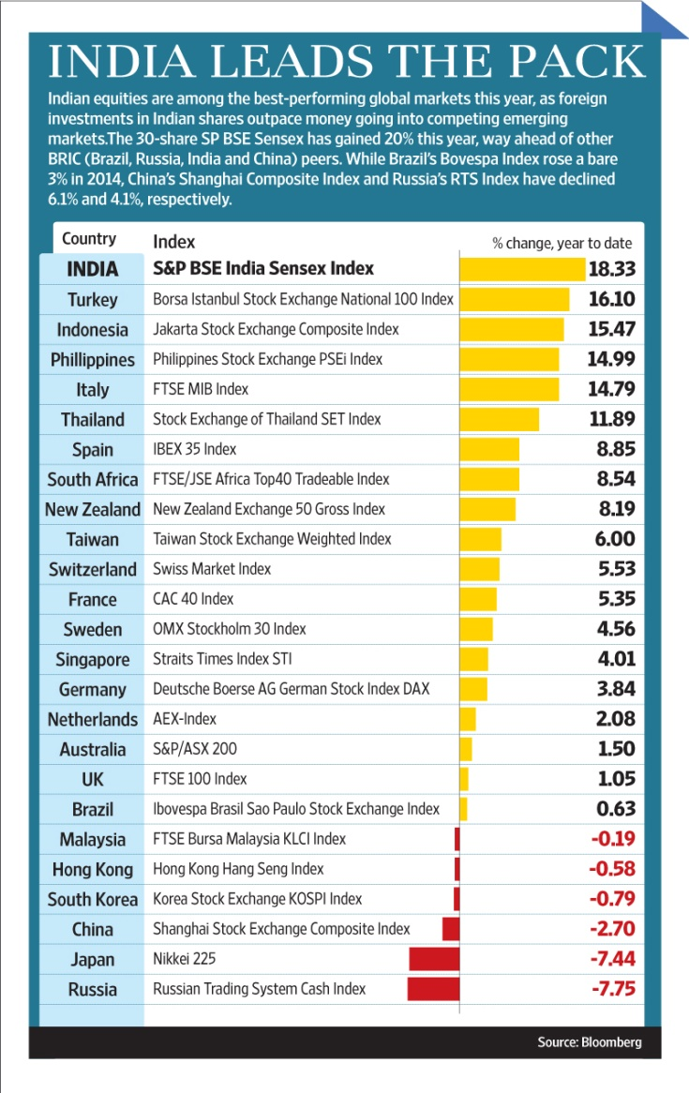
These short term spikes and toughs will matter little when one takes a view on businesses which have survived various economic downturns and prospered during upturns. Investors buy businesses and not stocks . Short term uncertainty does not cause Investors to loose sleep.

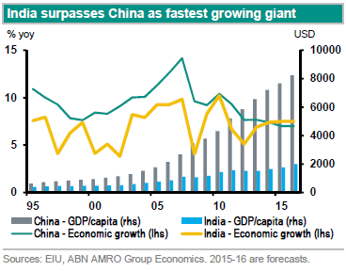
As we can see the GDP per capital of India is far behind China and this represents the opportunity for the next 25 years. A 5x increase in GDP per capital will mean that India will be a $10 trillion economy by 2030. Extrapolating that growth to Corporate Earnings and Stock Values 2016 represents the best year post the Economic crisis for investing in Stocks.
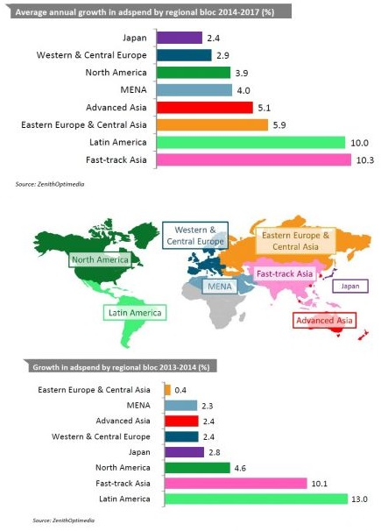
Our region is expected to grow Fastest even in 2017, therefore not just 2016 but also 2017 is expected to bring in robust wealth increase in India and the effects will be felt in Equity Markets.
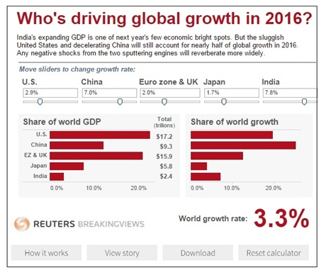
Currently India’s share of the global economic output is small but the good news is the growth rate of economic growth. India is in a sweet spot.
Are Investing in Indian Equities Risky?
To answer the above question we need to understand how Rupee has behaved
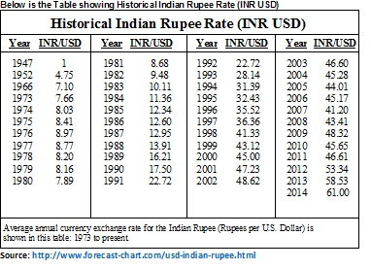
In December 2015 Rupee was at 66 to a USD threatening further round of weakening. This puts enormous pressure on costs of Imported raw material , Oil prices and imports of capital equipment.
Meanwhile we notice a healthy growth in the NRI depositing their savings in the country. The rates stood as follows
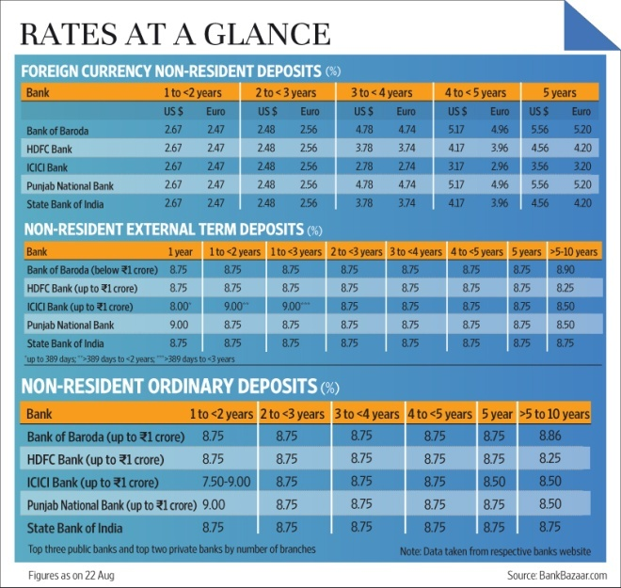
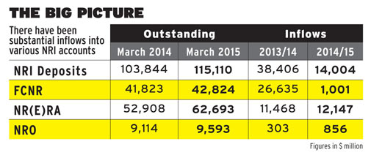
Thus the NRI community reposes confidence time and again.
Now we shall see the summary of our analysis of the market returns from 2009 till date. We shall see the returns an investor would have earn’t had he invested a sum of 100 way back in 2009 and on January 1st every year thereafter , naturally the earliest investment would have grown very well and the later like a sapling would have grown less. A smart investor would have remained invested and not just invested once but repeatedly disregarding the short term market sentiment. This is the investing style we advocate at Mentes Capital . Stay invested stay in the game.
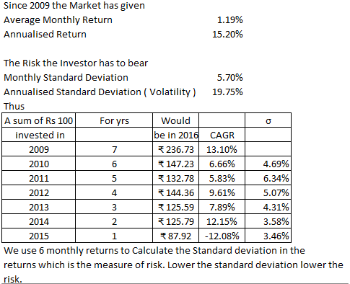
An Early Investor as the table shows below would be having a healthy CAGR of 13.1% and an investor for just 1 year would be looking at losses. But an Investor with the foresight provided by Mentes Capital today would be having a wealth of Rs 1000.39 after investing Rs 100 each year.
Now let us see the falling risk Investors have had to face in equity markets. We observe the standard deviation from 6 monthly returns and plot the same on the graph.
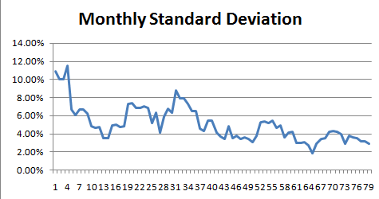
Clearly markets have become more stable which is good news for investors as we seen the 6 month moving average of the monthly standard deviation falls lower.

Conclusion:-
Thus after seeing the promise the macro economic indicators give to Corporate Earnings, the confidence reposed by NRI community and observing the historical performance of Indian Equity Markets we can safely say that allocating our risk capital under watchful eyes of a Professional Investment Advisory is actually the safe way to navigate the promising Indian Equity Markets .

