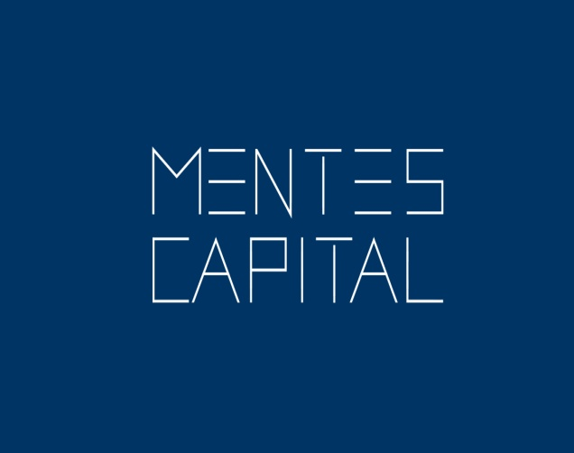

Contents:

Company Particulars, Key Drivers and Comparative Performance

Company Overview and Important Mile Stones

Product Portfolio

Industry Overview

Economic Forecast Relevant for Consumer Products Sales

Technical Analysis

Sector Analysis

Key Financial Observation

Funds that have invested in Marico

Some Stock Specific Statistics.

Long Term Price Chart

Shareholding Pattern

Valuation

Marico:-
BSE: 531642|NSE: MARICO|ISIN: INE196A01026|SECTOR: Personal Care
Key Drivers:-
Strong Brands, Sticky margins, Management focus on doubling revenues in 4 years. Strong correlation between Market Capatilization and Revenues in this sector.
CMP 256.25 Time Frame : 2 years
Target Rs 750 Recommendation : BUY
Comparative Performance:-
1M (%) 3M (%) 6M (%)
Marico Ltd 10.96 9.04 13.09
NIFTY (S&P CNX) 5.58 18.46 18.68
BSE Sensex 6.17 18.21 18.21
BSE 500 5.26 19.15 19.90
Company Overview:-
Marico Limited is one of India's leading consumer products companies operating in the beauty and wellness space. Empowered with freedom and opportunity, Currently present in 25 countries across emerging markets of Asia and Africa, Marico has nurtured multiple brands in the categories of hair care, skin care, health foods, male grooming, and fabric care. Marico's India business markets household brands such as Parachute Advansed, Saffola, Hair & Care, Nihar, Mediker, Revive, Manjal, Setwet, Zatak and Livon among others that is used by 1 in every 3 Indians.
The International business offers unique brands such as Parachute, Hair Code, Fiancee, Caivil, Hercules, BlackChic, Code 10, Ingwe, X-Men, L'Ovite and Thuan Phat that are localized to fulfil the lifestyle needs of their international consumers. Charting an annual turnover of Rs. 61 billion (Financial Year 2015 - 2016) across product portfolio, Marico Limited is an India-based company engaged in the business of branded consumer products and services. The company has presence in the Middle East, SAARC countries, Egypt, Myanmar, Malaysia, South Africa, Singapore, and Vietnam.
It offers coconut oil, hair oils, refined edible oils, anti-lice treatments, fabric care, functional and other processed foods, hair creams and gels, hair serums, shampoos, shower gels, hair relaxers and straighteners, deodorants, and other consumer products.
The Company operates in two segments: Consumer Products and Others. Its Consumer Products include Coconut oils, other edible oils, hair oils and other hair care products, male grooming products, fabric care products, healthy foods, soaps, health care products and female beauty care products.
Others segment is engaged in skin care. In India, Marico Limited manufactures and markets products under the brands such as Parachute Advansed, Saffola, Hair & Care, Nihar, Mediker, Revive, Manjal, Setwet, Zatak and Livon.
Marico’s international portfolio includes brands such as Parachute, Hair Code, Fiancee, Caivil, Hercules, BlackChic, Code 10, Ingwe, X-Men, L'Ovite and Thuan Phat. It is present in Skin Care solutions business under the brand name Kaya in India and international markets and the brand Derma Rx in Singapore and Malaysia. The Company currently present in 25 countries.
Important Mile Stones:-
2011 Marico strengthens its presence in southeast Asia through a male grooming, skin care and food portfolio acquired in Vietnam.
2007 Marico casts its footprint in Africa – acquires / Fiancee and Hair Code in Egypt and Caivil, Black Chic & Hercules in South Africa.
2003 Marico makes a difference – sets up copra collection centres to procure directly from farmers increasing their margins and thereby improving their lives.
1996 Marico lists on the Indian stock exchanges.
1991 Marico leadership co-creates its first Corporate Mission and Values document in the 3Ps of Marico.
Product Portfolio:-
Establishing brands in this sector involves heavy advertising and using celebrity brand endorsement . Both Brand creation and sustaining brand recall in the minds of the consumer at the point of purchase is critical for getting higher revenues.
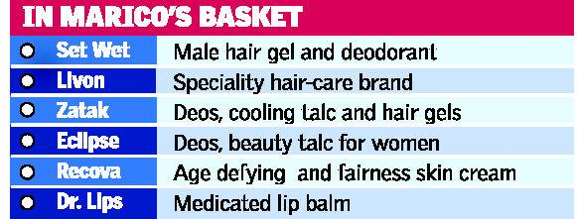
Higher revenues directly impact market capitalization in this sector.
Consumer Goods can be bifurcated into the following categories. This below image helps to know the drivers in consumption and how demographic changes coupled with higher education levels increases aspiration to consume such products.

Industry Overview:-
The FMCG sector has grown at an annual average of about 11 per cent over the last decade. The overall FMCG market is expected to increase at (CAGR) of 14.7 per cent to touch US$ 110.4 billion during 2012-2020, with the rural FMCG market anticipated to increase at a CAGR of 17.7 per cent to reach US$ 100 billion during 2012-2025.
Food products is the leading segment, accounting for 43 per cent of the overall market. Personal care (22 per cent) and fabric care (12 per cent) come next in terms of market share.
Growing awareness, easier access, and changing lifestyles have been the key growth drivers for the consumer market.

The Government of India's policies and regulatory frameworks such as relaxation of license rules and approval of 51 per cent foreign direct investment (FDI) in multi-brand and 100 per cent in single-brand retail are some of the major growth drivers for the consumer market.

Economic Forecast relevant for Consumer Products sales
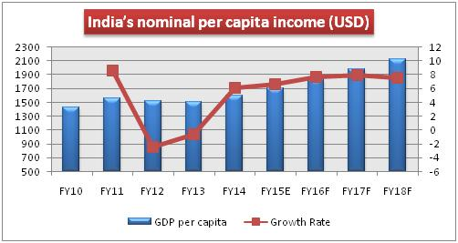

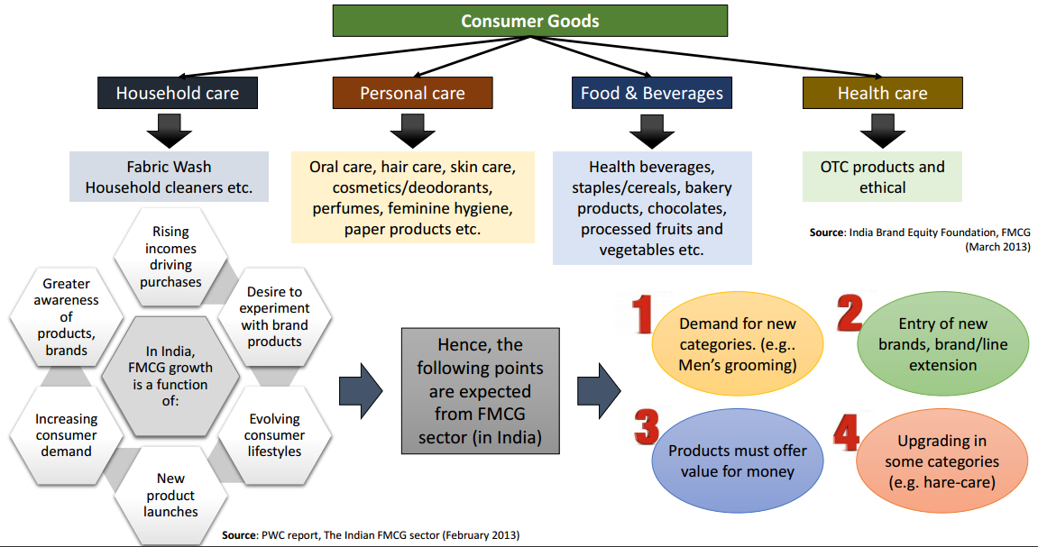

Many of their products will be used in any average household. Many are still aspirational and out of reach of millions of consumers. That will change once the general income levels rise both in urban and rural India.

Technical Analysis
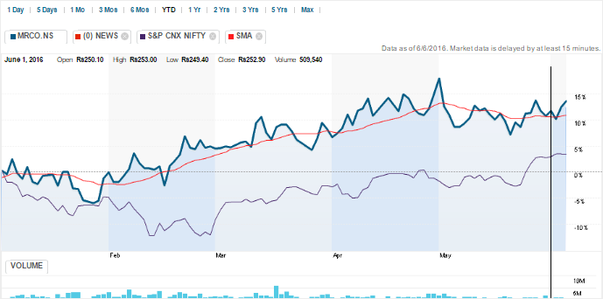
Stock has outperformed the Nifty and is currently above its moving average. YTM the stock has given 16% returns. NIFTY on the other hand as just about given returns of 5%
The stock has convincingly outperformed the FMCG index also over the past 1 year.
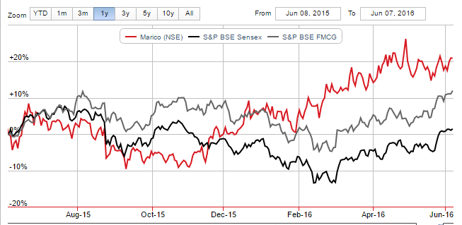

William % R:
Williams %R reflects the level of the close relative to the highest high for the look-back period. Williams %R oscillates from 0 to -100. Readings from 0 to -20 are considered overbought. Readings from -80 to -100 are considered oversold
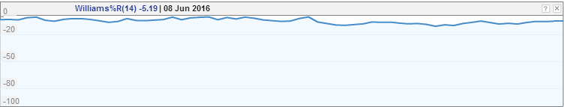

Relative Strength Index :
50 shows that the stock is neither over bought nor over sold. An asset is deemed to be overbought once the RSI approaches the 70 level, meaning that it may be getting overvalued and is a good candidate for a pullback. Likewise, if the RSI approaches 30, it is an indication that the asset may be getting oversold and therefore likely to become undervalued
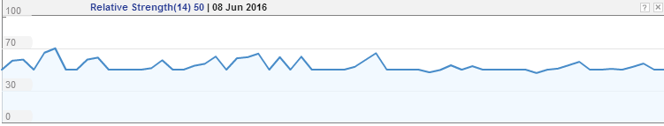
Sector Analysis
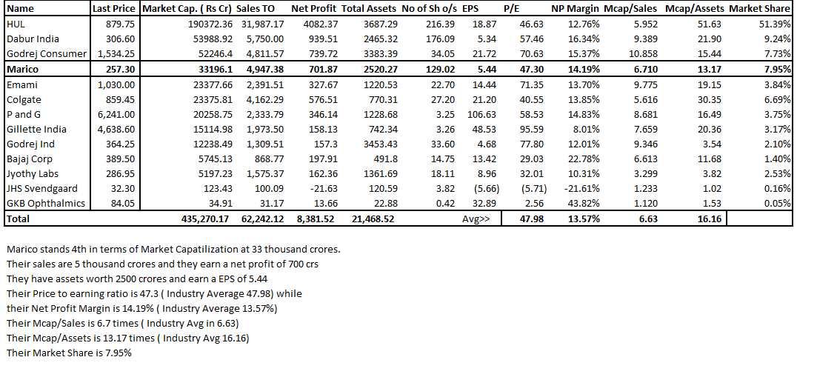
In the above sector analysis we look at peer group companies to identify a comparative companies approach to valuation of the company we are interested in . Here we have tabulated the EPS, P/E, Net Profit Margin, Valuation multiples of MCap/Sales and MCap/Assets. This information is very helpful in looking at the sector as a snapshot and compare the same class of companies.
Key Financial Observation :-
Now we identify key trends from the Balance sheet firstly and Profit and Loss account of this company.
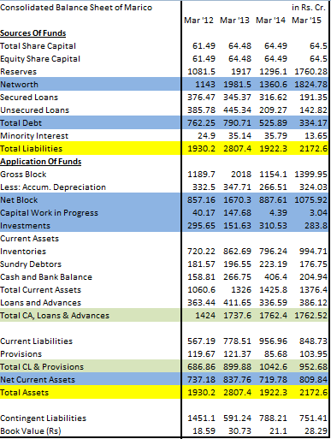
Over the past 4 years
Reserves have gone up by 63%
Net worth has grown by 60%
Debt is down 56%
Investments in Fixed Assets has grown 18%
Capital WIP is down 92%
Investments is marginally down by 4%
Inventories are up 38%
Debtors are down 2.65%
Cash is up 29.05%
Loans and Advances are up 6.24%
Current Liabilities are up 50%
Provisions are down 14%
Size of the Balance Sheet is up 12.56%
Proportion of Equity and Debt in the business was
60%:40% 4 year back and today it is 84% to 16%

Movement of Components of Assets over the previous years.
Shareholders capital contribution to Reserves is a quick way to tell how inherently profitable a business is. Especially for older companies like Marico. Well run well managed firms have 15 x to 20 x times Shareholder’s capital contributed in accumulated reserves.
Total Debt is a tiny fraction of the Capital Employed. This gives scope for more borrowing should need arise.
Capital WIP has ebbed over the past two years. This business does not demand enormous cash infusion both in Capex and in working capital investment which is a very good thing to have. Their products do not change thus no major reinvestment in R&D is required.
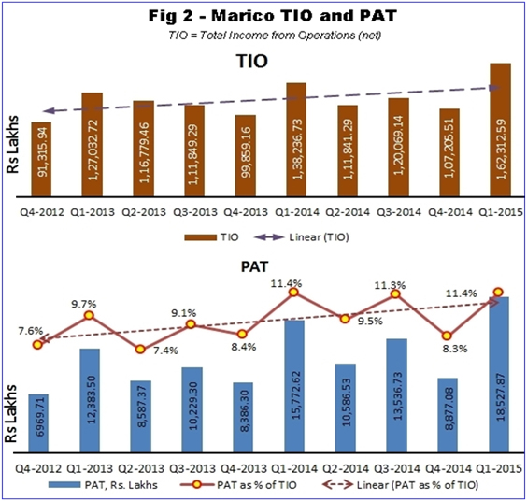
Notice the upward trend line both in Total Income From Operations and Profit after tax.
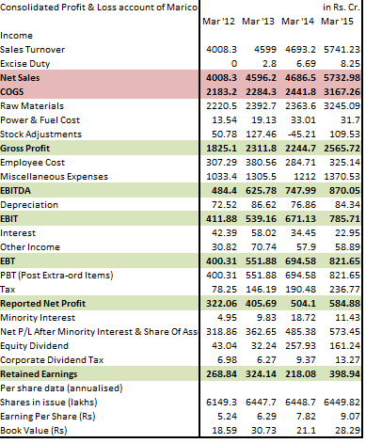

Sales has increased 44%
Cost of Goods Sold has Increased 43%
Material Cost has increased 46%
Power and Fuel cost has increased 134%
Employee cost has increased just 5.81%
Misc Expenses has increased 32.63%
Gross Profit Increased by 40%
EBITDA has increased 80%
EBIT has increased 90%
EBT has increased 105%
Net Income has increased 82%
Equity Dividends has increased 275%
Beta: 0.39
Market Cap(Mil.): Rs321,188.09
Shares Outstanding(Mil.): 1,290.17
Dividend: 1.00
Yield (%): 1.36

Margins
Mar '12 Mar '13 Mar '14 Mar '15
Gross Margin 45.53% 50.27% 47.83% 44.69%
EBITDA Margin 12.08% 13.61% 15.94% 15.15%
EBIT Margin 10.28% 11.72% 14.30% 13.69%
EBT Margin 9.99% 12.00% 14.80% 14.31%
PAT Margin 8.03% 8.82% 10.74% 10.19%
Turnover Ratios
Mar’12 Mar’13 Mar’14 Mar’15
Fixed Assets 3.28 2.74 2.83 4.27
Inventory 6.03 5.81 5.66 6.41
Debtors 20.62 22.72 22.36 28.71
Interest Cover Ratio 10.44 10.51 21.16 36.8
Annual Ratios (%)
1-Year 3-Years 5-Years
Growth
Revenue 22.33 12.94 16.59
Net Profit 16.02 22.00 20.15
EPS 18.13 19.91 18.52
Book Value 33.85 14.96 21.35
Average
Operating Margin 16.22 15.87 14.92
Net Margin 10.10 9.83 9.34
Return on Networth 36.76 30.96 32.27
ROI 39.35 31.55 29.81
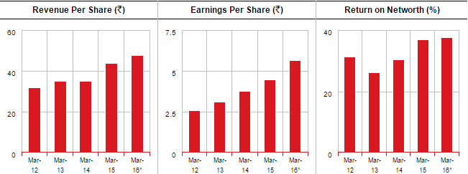
Funds Invested in Marico
Some of the best known funds have invested in Marico
Franklin Templeton Mutual Fund
UTI Mutual Fund
Edelweiss Mutual Fund
Birla Sun Life Mutual Fund
Reliance Mutual Fund
DHFL Pramerica Mutual Fund
LIC Mutual Fund
Kotak Mahindra Mutual Fund
IDFC Mutual Fund
Goldman Sachs Mutual Fund
We see some stock specific statistics now. :-
Nifty Marico
Average Monthly Returns 0.81% 2.22%
Annualised Returns 10.18% 30.22%
Monthly Standard Deviation 4.80% 5.68%
Volatility 16.64% 19.67%
Correlation 0.35
Coefficient of Determination 0.12 Low Market Risk
- Coeff of Fetermination) 0.88 High Firm Specific Risk
Beta 0.41
Alpha 1.89% Outperformer on Risk Adjusted Basis
Key Take Aways from the above analysis is that this stock is a positive alpha stock and it gives an annualized returns of 30%. It gyrates more than the market with higher standard deviation than the market. Low Market Risk is the only wrinkle in this otherwise perfect stock. Since the market rewards investors for bearing systematic risk ( market risk ) an average investor must hold stocks with high coefficient of determination . In this case Coefficient of Determination is low at 12% while firm specific factors that cause fluctuation is 88%.

Nifty Returns Vs Marico Returns

Long Term Chart
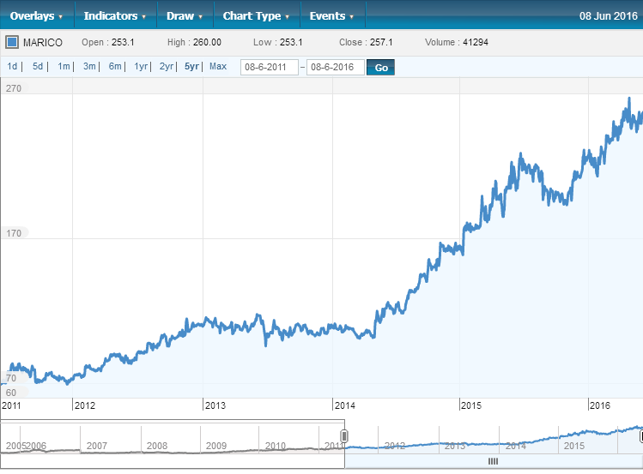
The 5 year price performance of this company is often a vertical rise. There is a sideways movement intermittently but the general long term trend has been upward.

SHAREHOLDING PATTERN
Promoters 59.67%
Mutual Funds / UTI 0.96%
FI / Banks 0.08%
Insurance 2.09%
Government 0.12%
FII 28.97%
Others 8.10%
Valuation:-
We use a 2 stage Discounted Cash Flow Approach to Value a Matured Company .
The value of any financial asset is the present value of its future cash flow. The Free Cash Flows to firm represents the maximum cash that can be withdrawn from the firm in any year without affecting the financial health of the firm and distributed to investors and used for loan repayment.
The assumptions into our model are on the left and the model on the right. We estimate there is value in buying this stock. This firm can be expected to sustain a high growth rate of 28% for the explicit forecast period of 10 years.
The major advantage for such firms is their products do not undergo drastic changes. Only product packaging needs to be updated keeping in mind consumer preferences. Thus excessive capital expenditure like in automobile sector to bring out new cars are not essential here.
Once the consumer gets used to say a Parachute Hair oil she will continue to use it for herself and her next generation. Further this firm’s stock is a low beta stock. This means the Market risk of the stock is low.
Out returns to justify investing in this stock ought to be low but this stock has consistently outperformed the FMCG and the broader market index NIFTY thus giving us superior returns compared to the risk we are taking.

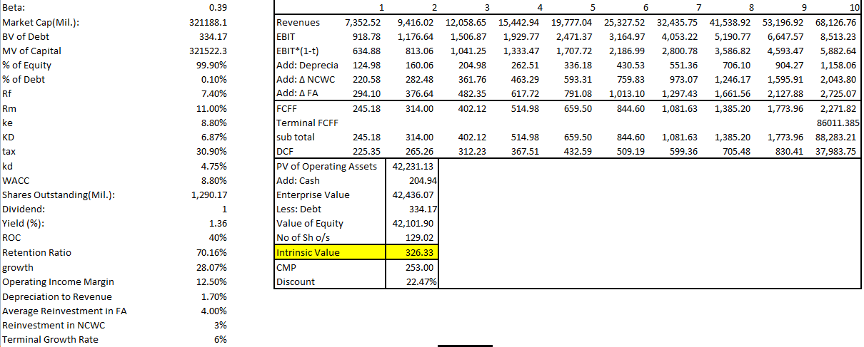

Annexure 1: Data from which Alpha, Beta, Correlation, Coefficient of Determination, Indexed to 100 returns for 5 years, standard deviation and volatility have been computed.
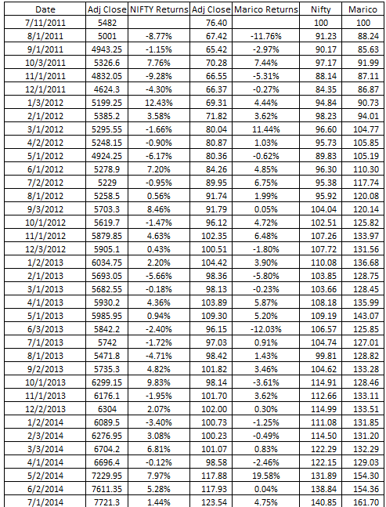
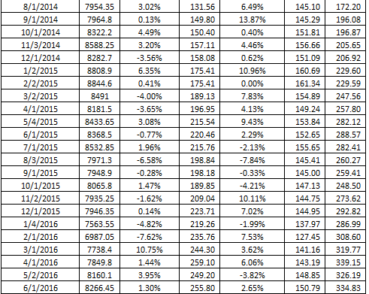
MENTES CAPITAL
WEB - WWW.MENTESCAPITAL.COM
PH.NO. - +91-9886751703, +91-9916570093
ADDRESS- #164,9th Cross, Indiranagar 1st Stage, Bangalore 560038

DISCLAIMER
*****************************************************************************
This information/email sent by Mentes capital may express financial guidance but these recommendation, advice, or guidance does not account for specific and particular financial goal and any suggestions, opinions conclusions stated in this information/email endorsed by us unless it is assigned. Mentes capital does not warrant the accuracy of any such information or appropriateness of any transaction. The information through this electronic communication and any attachments are for informational purposes only and no circumstance should they be affirmed as an offer to sell or a solicitation to buy any of Mentes products or any such reports. Risk of loss can be of any amount on this investment. You should take all the precaution while trading and investing is suitable for you in light of your experience, goal and other relevant circumstances. Mentes capital and its associate, employees, partners, subsidiary branch shall not be liable for any losses incurred by you. Trading and investments in financial markets are subjected to market risks therefore advised to seek professional support. There is no guarantee/assurance as to returns, capital protection and appreciation. It’s the sole responsibilities of the investors and traders for any decision taken by them. Any information in the email attachment is for recipient personal and confidential use. It is affirmed that dissemination, distribution or copying this information is strictly prohibited. There is a risk of modification in the information due to electronic nature of email. It’s not guaranteed that messages are virus free, malicious code. We are not liable for virus free. Please contact your relationship manager for more information on these risks. Past performance of actual trades or strategies cited herein is not necessarily indicative of future performance.
For detail disclaimer go to our website www.mentescapital.com.

