ASTEC LIFESCIENCES
MULTIBAGGER REPORT

CONTENTS

Executive Summary.........................................................................................3
Overview of the firm........................................................................................4
Growth of Healthcare sector in India..............................................................4
PESTLE Analysis…………………………………………………………...........6
Role of government with in the Health sector.................................................10
Role of WHO in India…………………………………………………………...13
History of the Firm............................................................................................16
Major events of the company............................................................................18
ASTEC Lifescience Ltd.....................................................................................20
ASTEC Lifescience Ltd. Share Holding...........................................................20
Financial Statement Analysis............................................................................21
Balance Sheet Observation................................................................................21
Growth Rate........................................................................................................22
Margins................................................................................................................22
Key Ratios............................................................................................................22
Sectorial Analysis of Pharmaceutical Industry.................................................23
Sectorial Analysis Methedology..........................................................................25
Cash Flow Model..................................................................................................26
Disclaimer………………………………………………………………………..29

Executive Summary:-

Astec is a producer of agrochemicals and pharmaceutical intermediates. It was established in 1994 with a focus on the Agrochemical and Pharmaceutical industries. Astec's considerable experience in the development and production of intermediates and active ingredients makes it an ideal partner. Astec has forged enduring relationships with large and small companies all over the world. Astec has an unshakeable reputation for providing quality products in manufacturing plants that meet global standards.
Providing leadership on matters critical to health and engaging in partnerships where joint action is needed. Shaping the research agenda and stimulating the generation, translation and dissemination of valuable knowledge. Setting norms and standards and promoting and monitoring their implementation. Articulating ethical and evidence-based policy options. Providing technical support, catalyzing change, and building sustainable institutional capacity. Monitoring the health situation and assessing health trends
Discounted Cash Flow is the gold standard for valuation of a firm. The Intrinsic Value of this firm is Rs 1,880 cr and the current Market Capital is only Rs 369.55 cr. That is an 80.34% discount. Which is why this stock is a potential multibagger.

Overview of the firm:-

Astec Lifesciences Ltd., incorporated in the year 1994, is a Small Cap company (having a market cap of Rs 364.59 Cr.) operating in Chemicals sector.
Astec Lifesciences Ltd. key Products/Revenue Segments include Agrochemicals which contributed Rs 267.02 Cr to Sales Value (99.81% of Total Sales), Other Operating Revenue which contributed Rs 0.49 Cr to Sales Value (0.18% of Total Sales), for the year ending 31-Mar-2015.
For the quarter ended 31-Dec-2015, the company has reported a Standalone sales of Rs. 42.49 Cr., down -31.12% from last quarter Sales of Rs. 61.68 Cr. and down -19.87% from last year same quarter Sales of Rs. 53.02 Cr. Company has reported net profit after tax of Rs. -17.00 Cr. in latest quarter.
The company’s management includes Mr.Ashok V Hiremath, Mr.Balram Yadav, Mr.Brahma Nand Vyas, Mr.N B Godrej, Mr.Rakesh Dogra, Mr.Sitendu Sharma, Mr.Vijay Kashinath Khot, Mr.Vinod Malshe, Ms.Tejal Jariwala, Mr.Ravindra Inani, Ms.Tejal Jariwala, Dr.Leena Raje, Mr.Arijit Mukherjee.
Company has Shah & Kathariya as its auditors. As on 31-Dec-2015, the company has a total of 19,455,055 shares outstanding.

Growth of Healthcare Sector in India:-
India being a country with growing population, country's per capita healthcare expenditure has increased at a CAGR of 10.3% from $43.1 in 2008 to $57.9 in 2011 and going forward this figure is expected to rise to $88.7 by 2015.
The factors behind the growth is rising incomes, easier access to high-quality healthcare facilities and greater awareness of personal health and hygiene, the report said.
The country's healthcare system is developing rapidly and it continues to expand its coverage, services and spending in both the public as well as private sectors, it said.
The private sector has emerged as a vibrant force in India's healthcare industry, lending it both national and international repute. Private sector's share in healthcare delivery is expected to increase from 66% in 2005 to 81% by 2015. Private sector's share in hospitals and hospital beds is estimated at 74% and 40%, respectively.
There is substantial demand for high-quality and special healthcare services in tier-II and tier-III cities. To encourage the private sector to establish hospitals in these cities, government has relaxed the taxes on these hospitals for the first 5 years.
Many healthcare players such as Fortis and Manipal Group are entering management contracts to provide an additional revenue stream to hospitals.
Over the years, health insurance is gaining momentum in India; gross healthcare insurance premium is expanding at a CAGR of 39% over FY06-10. This trend is likely to continue, benefitting the country's healthcare industry
Strong mobile technology infrastructure and launch of 4G is expected to drive mobile health initiatives in the country. Mobile health industry in India is expected to reach $0.6 billion by 2017, the report said.
To standardize the quality of service delivery, control cost and enhance patient engagement, healthcare providers are focusing on the technological aspect of healthcare delivery.
Digital health knowledge resources, electronic medical record, mobile healthcare, hospital information system are some of the technologies gaining acceptance in the sector. Going forward, the healthcare sector's spending on IT products and services is expected to rise from $53 billion in 2012 to $57 billion in 2013.
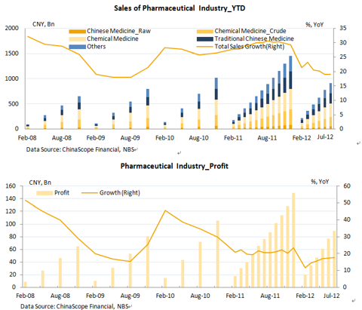

PESTLE Analysis of Pharmaceutical Industry
In the early 1990s and even earlier, macro environmental analysis was of little value to pharma firms. You needed to get a license for a brand or molecule, have the copycat (reverse engineering technology) procedure to manufacture, and then market it by employing MRs. Today, the situation is different, marketability of a pharma product or products of a healthcare enterprise, needs to have macro environmental analysis to be done continuously, to see how the political, legal, social, cultural, technological, environmental, ethical, economical, informational and other factors play and impinge on the firm's functioning.
In fact, the bigger the enterprise, the more it is impacted by macro environmental factors.

Political
There is now growing political focus and pressure on healthcare authorities across the world. This means that governments will be looking for savings across the board. Some of the questions the industry should ask are:
- What pressures will be put on pricing?
- What services will be cut?
- Will the same selection of drugs be available to everyone?
In addition to this, could there be more harmonization of healthcare systems across Europe or the USA? What impact will reforms have on insurance models?

Economic
The global economic crisis still exists yet government reports still show that the spend on healthcare per capital continues to grow. Will the current healthcare models exist tomorrow? The growth in homecare (as seen in the Nutrition sector) demonstrates how nursing services have moved to the private sector and have become a key business offering.
The reduction in consumer disposable income will have an impact on those countries using health insurance models particularly where part payment is required.
These economic pressures are seeing an increased growth in strategic buying groups who are forcing down prices.
Increased pressure from shareholders has caused a consolidation of the industry: more mergers and acquisitions will take place over the coming years.

Social / Culture
The increasing aging population offers a range of opportunities and threats to the pharmaceutical industry. The trick will be to capitalize on the opportunities.
There is also the problem of the increasing obesity amongst the population and its associated health risks.
Patients and home cares are becoming more informed. Their expectations have changed and they have become more demanding. Public activism has also increased through the harnessing of new social networking technologies. How can pharmaceutical companies get closer to consumers without over stepping the regulatory boundaries?

Technological
Technological advancements will create new business prospects both in terms of new therapy systems and service provisions. The online opportunities will see the growth in:
- New info and Communications technologies.
- Social Media for Healthcare.
- Customized Treatments.
- Direct to Patient Advertising.
- Direct to patient communications.

Legislation
The pharmaceutical industry has many regulatory and legislative restrictions. There is also a growing culture of litigation in many countries. The evolution of the internet is also stretching the legislative boundaries with patient’s demanding more rights in their healthcare programmes

Environmental
There is a growing environmental agenda and the key stake holders are now becoming more aware of the need for businesses to be more proactive in this field. Pharma companies need to see how their business and marketing plans link in with the environmental issues. There is also an opportunity to incorporate it within their Corporate Social Responsibility programmes. Marketing and new product development should identify eco opportunities to promote as well.
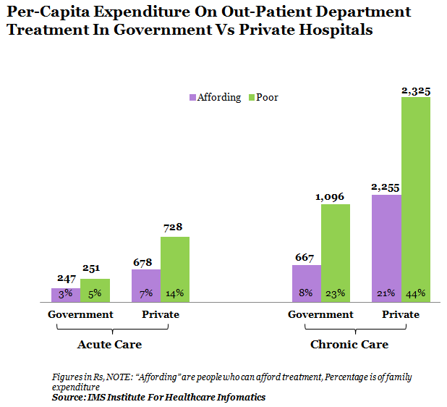

ROLE OF GOVERNMENT WITH IN THE HEALTH SECTOR

Health system strengthening
Important issues that the health systems must confront are lack of financial and material resources, health workforce issues and the stewardship challenge of implementing pro-equity health policies in a pluralistic environment. The National Rural Health Mission (NRHM) launched by the Government of India is a leap forward in establishing effective integration and convergence of health services and affecting architectural correction in the health care delivery system in India.

Health information system
The Integrated Disease Surveillance Project was set up to establish a dedicated highway of information relating to disease occurrence required for prevention and containment at the community level, but the slow pace of implementation is due to poor efforts in involving critical actors outside the public sector. Health profiles published by the government should be used to help communities prioritize their health problems and to inform local decision making. Public health laboratories have a good capacity to support the government's diagnostic and research activities on health risks and threats, but are not being utilized efficiently.

Health research system
There is a need for strengthening research infrastructure in the departments of community medicine in various institutes and to foster their partnerships with state health services.

Regulation and enforcement in public health
A good system of regulation is fundamental to successful public health outcomes. It reduces exposure to disease through enforcement of sanitary codes, e.g., water quality monitoring, slaughterhouse hygiene and food safety. Wide gaps exist in the enforcement, monitoring and evaluation, resulting in a weak public health system. This is partly due to poor financing for public health, lack of leadership and commitment of public health functionaries and lack of community involvement. Revival of public health regulation through concerted efforts by the government is possible through updating and implementation of public health laws, consulting stakeholders and increasing public awareness of existing laws and their enforcement procedures.

Health promotion
Stopping the spread of STDs and HIV/AIDS, helping youth recognize the dangers of tobacco smoking and promoting physical activity. These are a few examples of behavior change communication that focus on ways that encourage people to make healthy choices. Development of community-wide education programs and other health promotion activities need to be strengthened.

Human resource development and capacity building
There are several shortfalls that need to be addressed in the development of human resources for public health services. There is a dire need to establish training facilities for public health specialists along with identifying the scope for their contribution in the field. The Public Health Foundation of India is a positive step to redress the limited institutional capacity in India by strengthening training, research and policy development in public health. Preservice training is essential to train the medical workforce in public health leadership and to impart skills required for the practice of public health.

Public health policy
Identification of health objectives and targets is one of the more visible strategies to direct the activities of the health sector, e.g. in the United States, the “Healthy People 2010” offers a simple but powerful idea by providing health objectives in a format that enables diverse groups to combine their efforts and work as a team. Similarly, in India, we need a road map to “better health for all” that can be used by states, communities, professional organizations and all sectors.

Scope for further action in the health sector
School health, mental health, referral system and urban health remain as weak links in India's health system, despite featuring in the national health policy. School health programs have become almost defunct because of administrative, managerial and logistic problems. Mental health has remained elusive even after implementing the National Mental Health Program.
On a positive note, innovative schemes through public-private partnerships are being tried in various parts of the country in promoting referrals. Similarly, the much awaited National Urban Health Mission might offer solutions with regards to urban health.
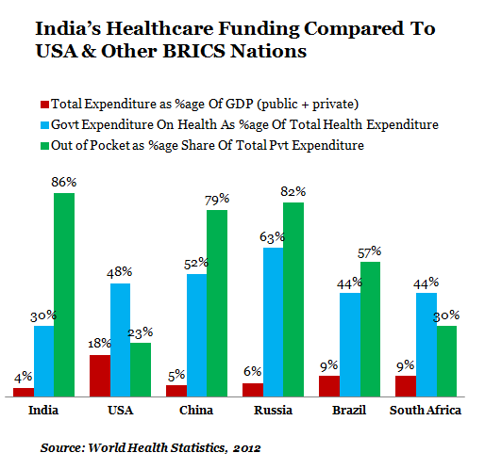

Role of WHO in India
World Health Organization (WHO) is the United Nations’ specialized agency for Health. It is an inter-governmental organization and works in collaboration with its member states usually through the Ministries of Health. The World Health Organization is responsible for providing leadership on global health matters, shaping the health research agenda, setting norms and standards, articulating evidence-based policy options, providing technical support to countries and monitoring and assessing health trends.
India became a party to the WHO Constitution on 12 January 1948. The first session of the WHO Regional Committee for South-East Asia was held on 4-5 October 1948 in the office of the Indian Minister of Health. It was inaugurated by Pandit Jawaharlal Nehru, Prime Minister of India and was addressed by the WHO Director-General, Dr Brock Chisholm. India is a Member State of the WHO South East Asia Region.
Dr HenkBekedam is the WHO Representative to India.
The WHO Country Office for India is headquartered in Delhi with country-wide presence. The WHO Country Office for India’s areas of work are enshrined in its new Country Cooperation Strategy (CCS) 2012-2017.
WHO is staffed by health professionals, other experts and support staff working at headquarters in Geneva, six regional offices and country offices. In carrying out its activities and fulfilling its objectives, WHO's secretariat focuses its work on the following six core functions:
- providing leadership on matters critical to health and engaging in partnerships where joint action is needed;
- shaping the research agenda and stimulating the generation, translation and dissemination of valuable knowledge;
- setting norms and standards and promoting and monitoring their implementation;
- articulating ethical and evidence-based policy options;
- providing technical support, catalysing change, and building sustainable institutional capacity; and
- monitoring the health situation and assessing health trends.
These core functions are set out in the 11th General Programme of Work, which provides the framework for organization-wide programme of work, budget, resources and results. Entitled "Engaging for health", it covers the 10-year period from 2006 to 2015.

Country Cooperation Strategy (CCS) 2012-2017
The WHO Country Cooperation Strategy – India (2012-2017) has been jointly developed by the Ministry of Health and Family Welfare (MoH&FW) of the Government of India (GoI) and the WHO Country Office for India (WCO). Its key aim is to contribute to improving health and equity in India. It distinguishes and addresses both the challenges to unleashing India’s potential globally and the challenges to solving long-standing health and health service delivery problems internally.
The CCS incorporates the valuable recommendations of key stakeholders garnered through extensive consultations. It balances country priorities with WHO’s strategic orientations and comparative advantages in order to contribute optimally to national health development. It includes work on “inter-sectoral” actions, regulations and reform of the provision of (personal and population) health services that impact on the health system outcomes – health status, financial protection, responsiveness and performance.
To contribute meaningfully to the national health policy processes and government’s health agenda, the CCS has identified three strategic priorities and the focus areas under each priority:

Strategic priority 1: Supporting an improved role of the Government of India in global health
- International Health Regulations: Ensuring the implementation of International Health Regulations and similar commitments.
- Pharmaceuticals: Strengthening the pharmaceutical sector including drug regulatory capacity and, trade and health.
- Stewardship: Improving the stewardship capacity of the entire Indian health system

Strategic priority 2: Promoting access to and utilization of affordable, efficiently networked and sustainable quality services by the entire population
- Financial Protection: Providing universal health service coverage so that every individual would achieve health gain from a health intervention when needed.
- Quality: Properly accrediting service delivery institutions (primary health care facilities and hospitals) to deliver the agreed service package.

Strategic priority 3: Helping to confront the new epidemiological reality of India
- Health of Mothers and Children: Scaling up reproductive, maternal, newborn, child and adolescent health services.
- Combined Morbidity: Addressing increased combinations of communicable and noncommunicable diseases.
- Transitioning Services: Gradual, phased “transfer strategy” of WHO services to the national, state and local authorities without erosion of effectiveness during the transition period.
Achievement of the CCS objectives calls for major adaptations in the way the WCO plans, works, organizes and delivers measurable results towards the goal of ensuring better health for all Indians in collaboration with the government and other partners.
The critical challenge for the WCO will be to adjust and scale up its capacity to provide support for the required technical excellence that would enable meaningful contributions to national health policy processes, and the government’s health agenda. The CCS implementation will be based on two-year Action Plans developed by the WCO in consultation with the MoHFW taking due consideration of the health priorities envisaged by the 12th Five Year Plan.

History of the firm
The company was incorporated on January 25, 1994 under the Companies Act, 1956 as Urshila Traders Private Limited.It was originally promoted by Mrs. Reena Bagai and Mrs. Avita Fernandes. Their shareholding was purchased by Mr. Ashok V Hiremath and Mr. Pratap Garud on February 11, 1994. The name of the Company was changed to Astec Chemicals Private Limited on August 19, 1994 and further to Astec LifeSciences Private Limited on March 3, 2006. With effect from April 27, 2006, Astec LifeSciences Private Limited was converted into a public limited company under the name of "Astec LifeSciences Limited".
They carry out manufacturing activities at two locations in Maharashtra, India comprising of three units in Maharashtra viz. one unit at Dombivli and two units at Mahad (Unit 1 and Unit 2). The first manufacturing unit in August 1994 by acquiring a sick unit in Dombivli, Maharashtra having an installed capacity of 120 MT for the manufacture of Dicap, a pharmaceutical intermediate.
With a view to expand operations, they entered into an agreement with Behram Chemicals Private Limited on February 18, 2002 for using and operating their manufacturing facilities located at B-16, Mahad Industrial Area, Sub-District Mahad, District Raigad, Maharashtra. Behram Chemicals Private Limited was engaged in manufacture of chemicals and pesticides having an installed capacity of 130 MT.
Behram Chemicals Private Limited was initially promoted by Mr. Jehangir J. Mistry, Mrs. Villoo J. Mistry, Mrs. Kamla G. Sippy and Mr. Surinder Kumar Verma in April, 1993. During August, 1998 further shares were allotted to M.C. Chemicals and some members of Gangani family viz. Mr. Nasrudin K Gangani, Mr. S. N. Gangani, Mrs. N. N. Gangani, Mr. T. K. Gangani and Khoja Bone Mills Private Limited (a company promoted by Gangani family). Looking at the potential in Behram Chemicals Private Limited, the Company has acquired 65.63% share by entering into Share Purchase Agreement with the above members of Gangani family on April 2, 2007. Mr. Jehangir J. Mistry, Mrs. Villoo J. Mistry, Mrs. Kamla G. Sippy and Mr. Surinder Kumar Verma, M.C. Chemicals and Gangani family are not related to the Promoters / the Directors in any manner in any capacity whatsoever. With this acquisition, Behram Chemicals Private Limited became a subsidiary of this Company.
During 2003-04 they expanded total installed capacity of the units (Dombivli and Mahad) from 250 MT to 500 MT. They renewed the agreement on August 1, 2004 for a further period of 66 months ending on January 31, 2010
In 2004, they acquired a plot located at B-17, Mahad, Maharashtra and set up a new manufacturing facility as an Export Oriented Unit (EOU) in the year 2005 (as Unit 2) which is located adjacent to Unit 1 with an installed capacity of 1000 MT. With the commissioning of Unit 2 our total installed capacity increased to 1500 MT. They further expanded total capacities to 2000 MT during 2006- 07 and to 2500 MT during 2007-08.
The company is primarily involved in the production of active ingredients and intermediates for agrochemicals and pharmaceutical segment. Hexaconazole, Tebuconazole, Metalaxyl and Propiconazole are some of their key products in agrochemical segment which are generally used in crop protection and Dicap is one of our key Pharmaceutical intermediate which is used in manufacture of antifungal agents. Triazole fungicides, which includes Hexaconazole, Tebuconazole, and Propiconazole is one of our major product in the agrochemical segment, and has contributed 63.67% to our total sales whereas Dicap, a key product in pharmaceutical segment has contributed 9.01% during FY 2007-08.
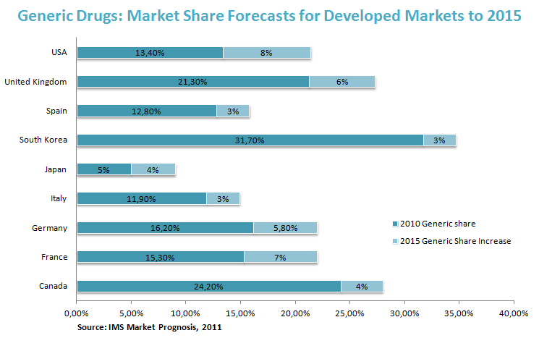
Major Events of the Company
Period Events
January 1994 Incorporation of Urshila Traders Private Limited
August 1994 Change of name to Astec Chemicals Private Limited
August 1994 Commenced first manufacturing unit at Dombivli, Maharashtra
May, 2001 Certified ISO 9002 by International Standards Certification Pty Limited, Australia
February 2002 Entered into an agreement with Behram Chemicals Private Limited
March 2005 Re-certified ISO 9001:2000 by International Standards Certification Pty Limited, Australia
May 2005 Commenced another manufacturing unit (Unit 2) as Export Oriented Unit at Mahad, Maharashtra
March 2006 Change of name to Astec Life Sciences Private Limited
April 2006 Conversion of the Company from a private limited company to a public limited company
January 2007 Established Astec Europe in Tournai, Belgium
April 2007 Behram Chemicals Private Limited became a subsidiary by acquisition of 65.63% vide Share Purchase Agreement dated April 2, 2007
2011 -Registered Office of the Company has been shifted 5, 5-A, 4th Floor, Kamanwala Chambers, Sir P. M. Road, Fort, Mumbai - 400001 To Elite Square, 7th Floor, 274, Perin Nariman Street, Fort, Mumbai - 400001.
2012 - Astec has entered into an exclusive long term contract with a multinational company to manufacture and supply a fungicide
- Astec Recommended a dividend of fifty paise per share (i.e. 5% on the face value of Rs.10/- each)
2013 -Astec Lifesciences Ltd has Recommended a dividend of Seventy Five paise per share (i.e. 7.5% on face value of Rs. 10/- each). -Mr. Ravindra Inani as Chief Financial Officer (CFO) of the Company.
2014 -Appointed Dr. Leena Raje as the new Woman Director. -Astec Lifesciences Ltd has recommend enhanced dividend of Rupee One per share (i.e. 10% on the face value of Rs. 10/- each.

Now we shall look at the Peer Group Comparison we look at a very high 737.14% over the past 3 years. Even at this levels it is a great buy.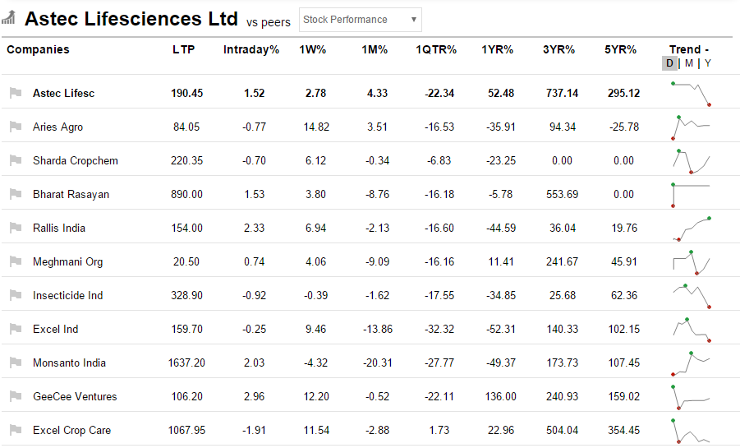
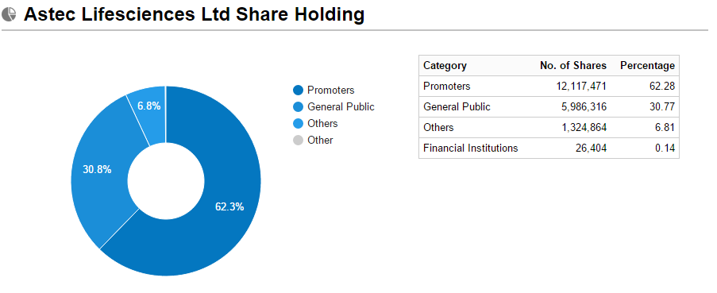

Financial Statement Analysis
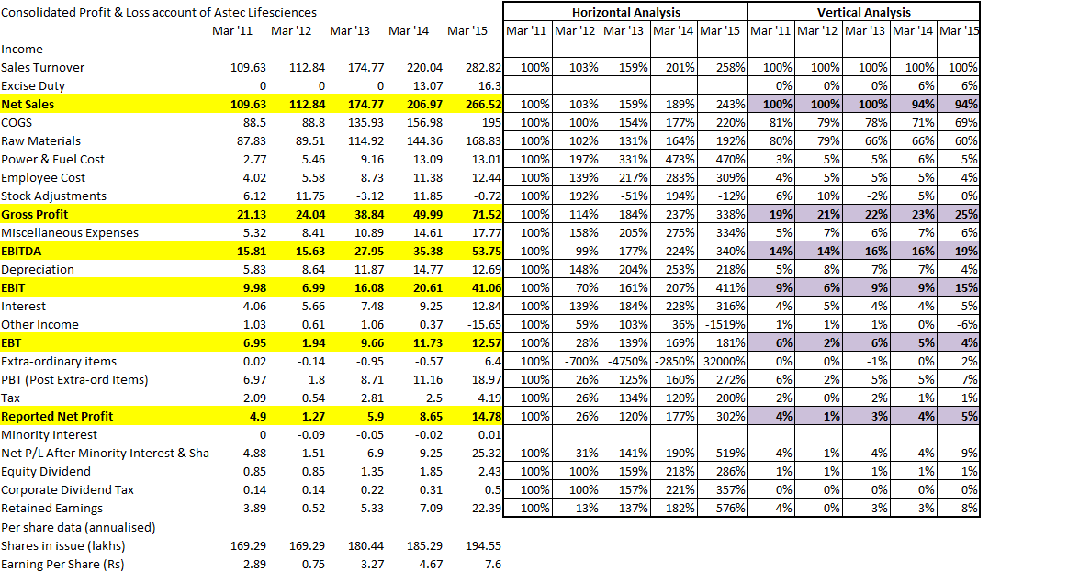
Balance Sheet Observation
a) Debt has doubled
b) Networth increased by CAGR of 7.08% p.a
c) Debt Equity was 0.41 , 5 years back and today it is 0.62 today.
d) Receivables build up strains Cash cycle we see a buildup.
e) Reserves have gone up 7.90% CAGR p.a
f) Reinvestment in Fixed Assets have doubled.
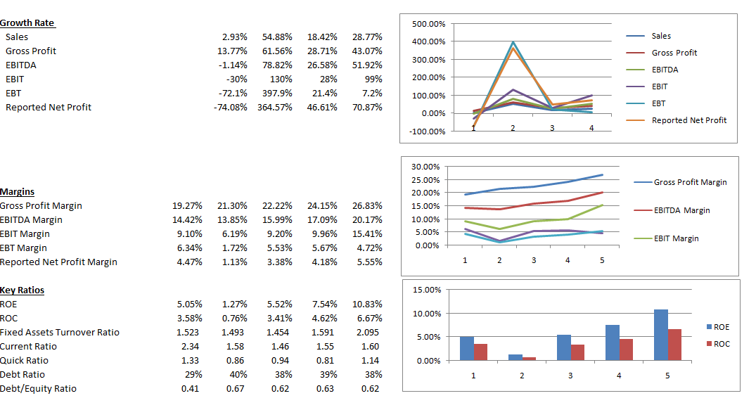

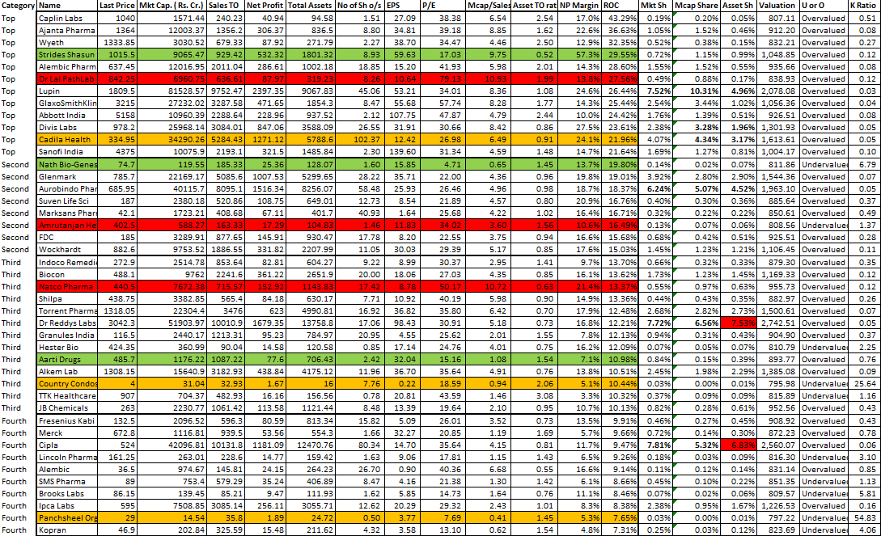
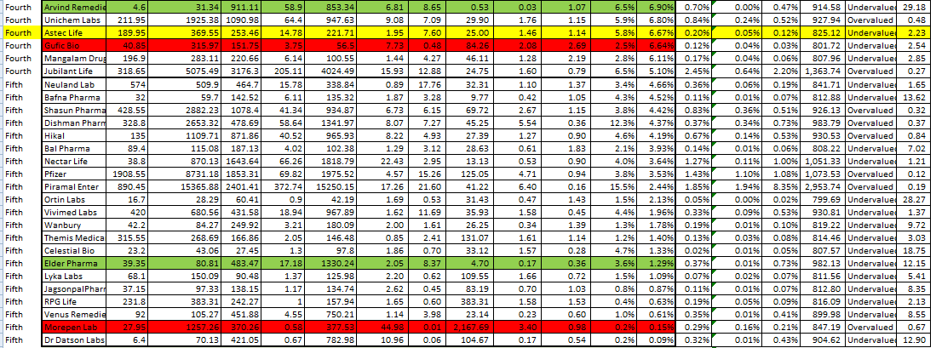
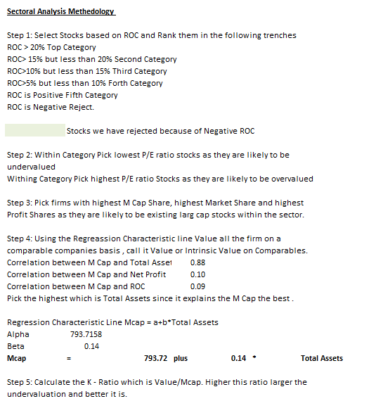
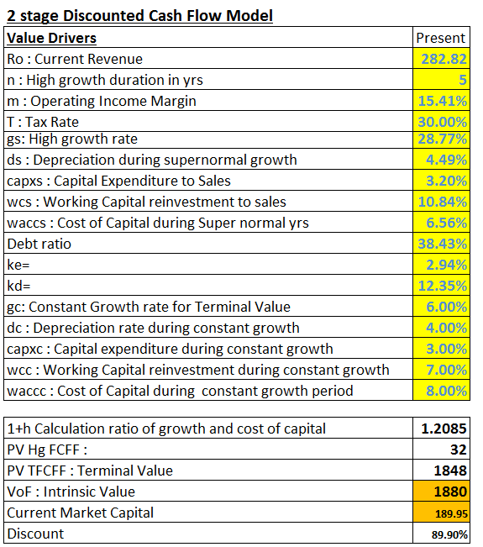
Discounted Cash Flow is the gold standard for valuation of a firm. The Intrinsic Value of this firm is Rs 1,880 cr and the current Market Capital is only Rs 369.55 cr. That is an 80.34% discount. Which is why this stock is a potential multibagger.
Now we shall see how this stock has performed for the past 60 months. We shall compare it with the market.

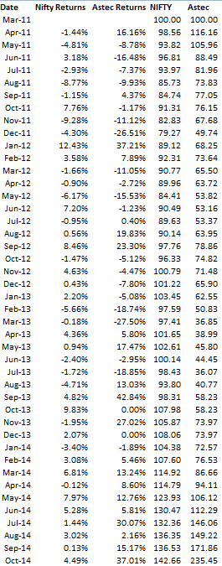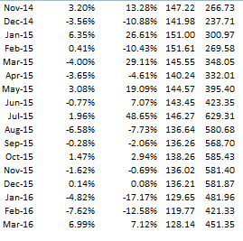
We see the interpretation of this data below.
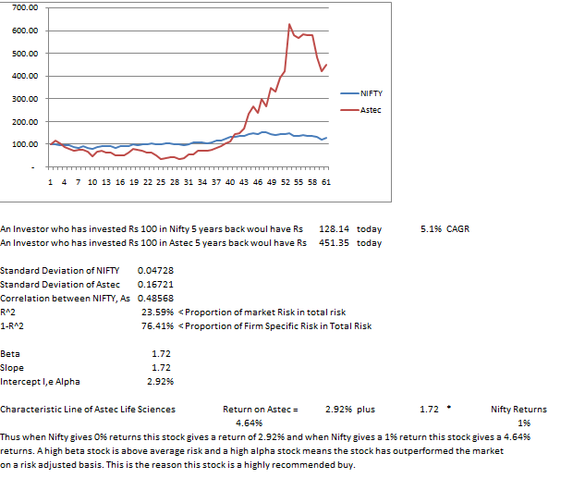

MENTES CAPITAL
WEB - WWW.MENTESCAPITAL.COM
PH.NO. - +91-9886751703, +91-9916570093
ADDRESS- #164,9th Cross, Indiranagar 1st Stage, Bangalore 560038

DISCLAIMER
*****************************************************************************
This information/email sent by Mentes capital may express financial guidance but these recommendation, advice, or guidance does not account for specific and particular financial goal and any suggestions, opinions conclusions stated in this information/email endorsed by us unless it is assigned. Mentes capital does not warrant the accuracy of any such information or appropriateness of any transaction. The information through this electronic communication and any attachments are for informational purposes only and no circumstance should they be affirmed as an offer to sell or a solicitation to buy any of Mentes products or any such reports. Risk of loss can be of any amount on this investment. You should take all the precaution while trading and investing is suitable for you in light of your experience, goal and other relevant circumstances. Mentes capital and its associate, employees, partners, subsidiary branch shall not be liable for any losses incurred by you. Trading and investments in financial markets are subjected to market risks therefore advised to seek professional support. There is no guarantee/assurance as to returns, capital protection and appreciation. It’s the sole responsibilities of the investors and traders for any decision taken by them. Any information in the email attachment is for recipient personal and confidential use. It is affirmed that dissemination, distribution or copying this information is strictly prohibited. There is a risk of modification in the information due to electronic nature of email. It’s not guaranteed that messages are virus free, malicious code. We are not liable for virus free. Please contact your relationship manager for more information on these risks. Past performance of actual trades or strategies cited herein is not necessarily indicative of future performance.
For detail disclaimer go to our website www.mentescapital.com.

