Title : Sectoral analysis of Realty
Date of the Report : 13th November 13, 2015

Introduction and Methedology
Realty as we all know is a key driver for economic growth and connects up with more than 270 sectors and is a prime employment generator. Here we look at the listed companies in this space as of today and see which of the stocks are worth investing in.
The raw data for this analysis was sourced from Moneycontrol.com . Upon that following further calculation was done and we base our conclusions on the results of these results.
- Market Capatilisation /Last Price of the stock = No of Shares o/s
- Net Profit / No of Sh o/s = Earnings Per Share
- Sales TO /No of Share o/s = Revenue per share.
- Net Profit / Sales TP = NP Margin
- MCap/Sales, MCap/Total Assets, MCap/Net Income are the Valuation Multiples
- Turnover/Total Turnover = Market Share
- Total Assets of the Firm/Total Assets deployed in this sector = Asset Share
- Last Price / EPS = P/E ratio
Comparative Companies Approach to Analysis
Approach followed to Rank the Firms is as follows:-
- First Iteration based on P/E ratio
- Second Iteration Based on Market Share with a cut off below 1% and below 5%
- Last Iteration based on Net Profit Margin.
Thus DLF, Oberoi Realty and Nitesh Estates emerge in the three classes as front runners in the Matured Growth, High Growth and Emerging Firms.

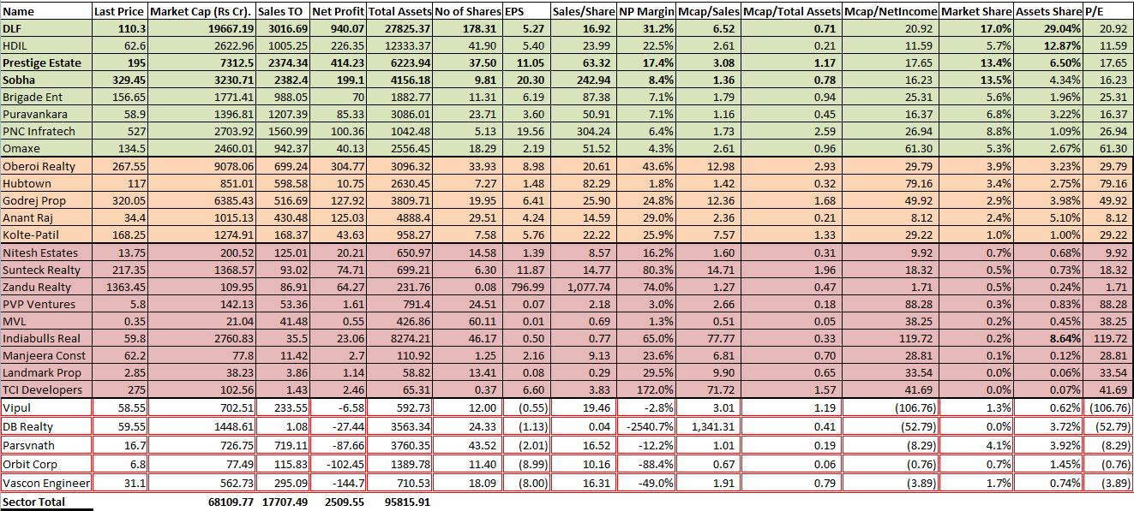
Now we shall look at the performance of this sector for a short duration of 5 days. We see the sector in a bearish phase . The Parabolic Sar is a series of Gree and Red dot indicating the commencement of a bull run or a bearish phase in the sector. For most part of this week the MACD is below zero further indicating a sell off. 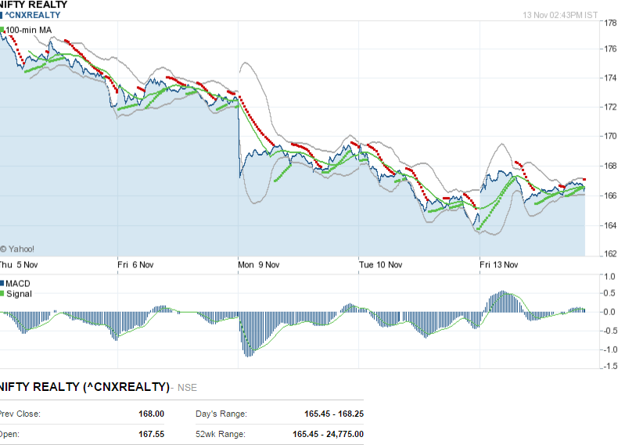
Now we shall finally see how this sector Index has performed .
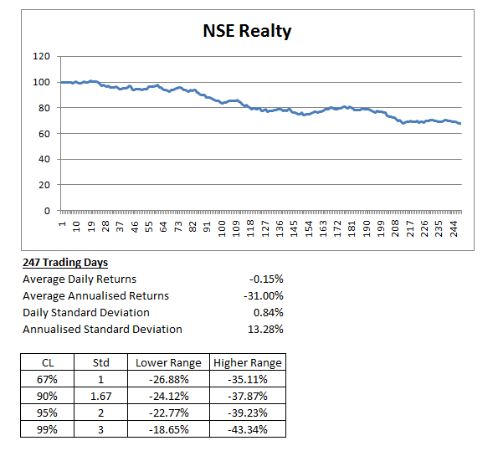
The sector is down 31% in the past 1 year and given above is the expectation of a bounce back going forward is minimal to nil. This sector has deep systemic issues which only regulators and government can solve. We see a range bound index between 9000 to 8000.
MENTES CAPITAL
WEB:- www.mentescapital.com
PH.NO:- +91-9886751703, +91-9916570093
ADDRESS- #164, 9th cross, Indiranagar 1st stage, Bangalore 560038
DISCLAIMER
*****************************************************************************
This information/email sent by Mentes capital may express financial guidance but these recommendation, advice, or guidance does not account for specific and particular financial goal and any suggestions, opinions conclusions stated in this information/email endorsed by us unless it is assigned. Mentes capital does not warrant the accuracy of any such information or appropriateness of any transaction. The information through this electronic communication and any attachments are for informational purposes only and no circumstance should they be affirmed as an offer to sell or a solicitation to buy any of Mentes products or any such reports. Risk of loss can be of any amount on this investment. You should take all the precaution while trading and investing is suitable for you in light of your experience, goal and other relevant circumstances. Mentes capital and its associate, employees, partners, subsidiary branch shall not be liable for any losses incurred by you. Trading and investments in financial markets are subjected to market risks therefore advised to seek professional support. There is no guarantee/assurance as to returns, capital protection and appreciation. It’s the sole responsibilities of the investors and traders for any decision taken by them. Any information in the email attachment is for recipient personal and confidential use. It is affirmed that dissemination, distribution or copying this information is strictly prohibited. There is a risk of modification in the information due to electronic nature of email. It’s not guaranteed that messages are virus free, malicious code. We are not liable for virus free. Please contact your relationship manager for more information on these risks. Past performance of actual trades or strategies cited herein is not necessarily indicative of future performance.
For detail disclaimer go to our website www.mentescapital.com.

